português – verbos
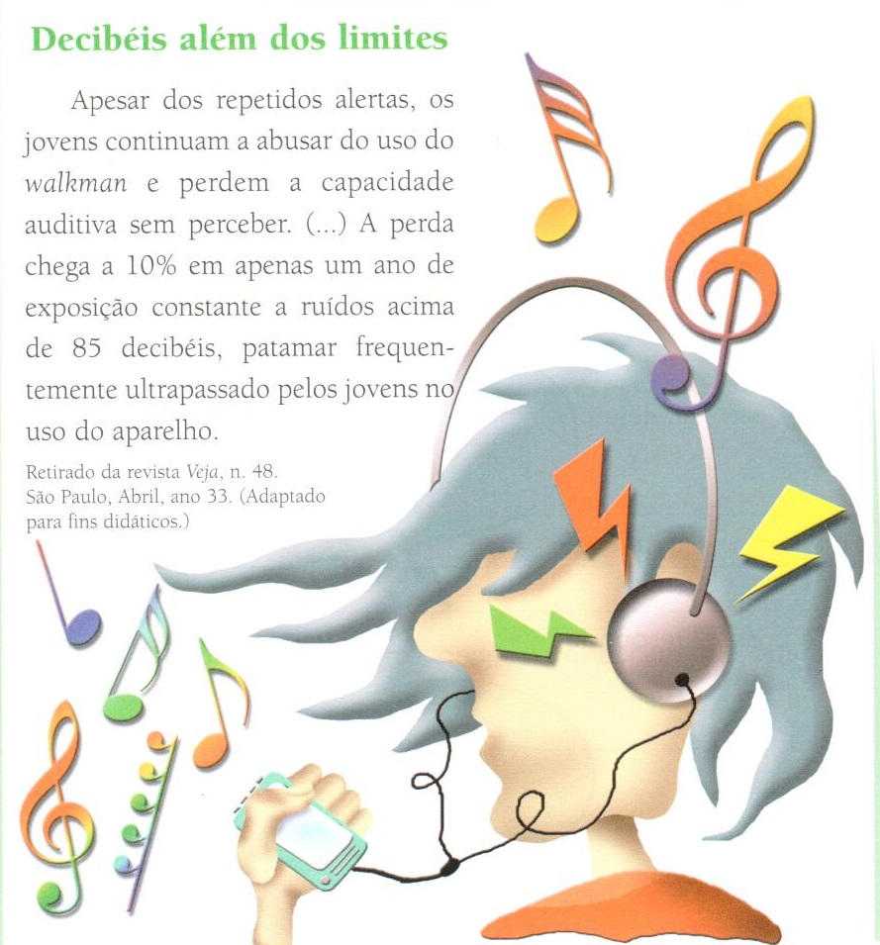

Leia este trecho e responda:

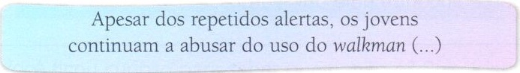

- A afirmativa acima está escrita no presente, passado ou futuro?
_______________________________________________________________
- Reescreva a afirmativa no passado para ver como fica.
________________________________________________________________________________________________________________________________________________________________________________________________________________________________________________________________________________________________________

- Reescreva o texto Decibéis além dos limites para o passado e sublinhe os verbos modificados.
____________________________________________________________________________________________________________________________________________________
________________________________________________________________________________________________________________________________________________________________________________________________________________________________________________________________________________________________________________________________________________________________________________________________________________________________________________________________________________________________________________________________________________________________________________________________________________

- Escreva o que você entende sobre: substantivo, adjetivo, verbo. Cite exemplos.
Se necessário, pesquise em livros e gramáticas.
____________________________________________________________________________________________________________________________________________________________________________________________________________________________________________________________________________________________________________________________________________________________________________________________________________________________________________________________________________________________________________________________________________________________________________________________________________________________________________________________________________________________________________________________________________________________________________________________________________________________________________________________________________________________________________________________________________________________________________________________________________________________________________________________________________________________________________________________________________________________________________________________________________________________________________________________________________________________________________________________________________________________________________________

