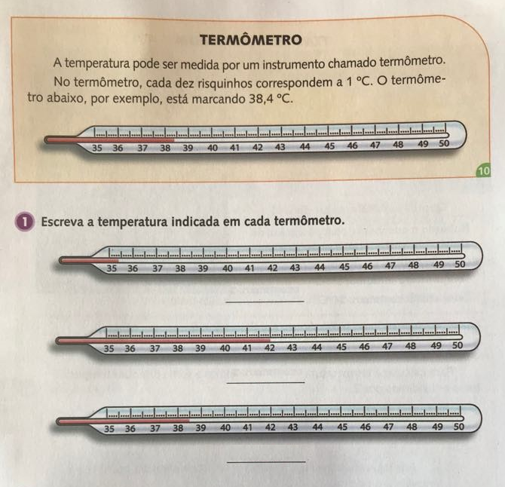
MATEmática




