português – uso da vírgula
- Leia um trecho de um conto escrito por um aluno do 4º ano.
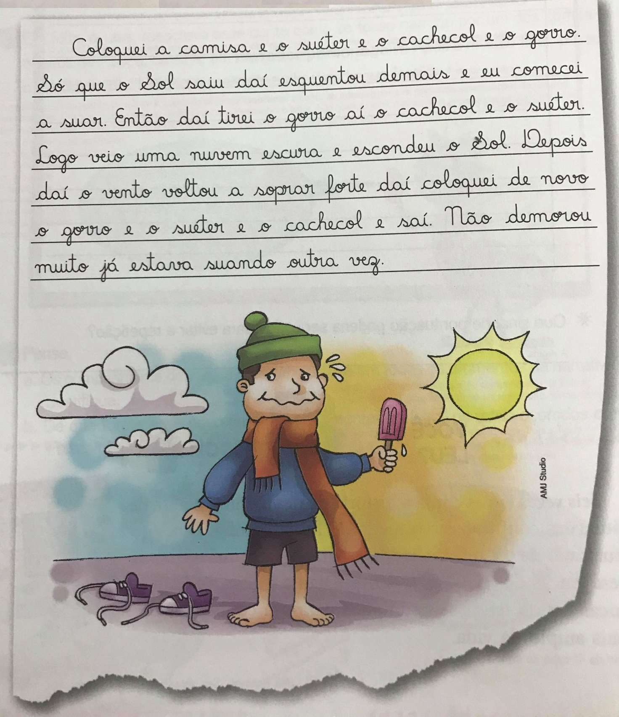

- Responda:
- Há palavras repetidas desnecessariamente no texto? Quais?
____________________________________________________________________________________________________________________________________________________________________________________________________________________________________________________________________________________________________________________________________________________
- Reescreva esse trecho fazendo a substituição.
________________________________________________________________________________________________________________________________________________________________________________________________________________________________________________________________________________________________________________________________________________________________________________________________________________________________________________________________________________________________________________________________________________________________________________________________________________________________________________________________________________________________________________________________________________________________________________________________________________________________________________________________________________________________________________________________________________________________________________________________________________________________________________________________________________________________________________________________________________________________________________________________________________________________________________________________________________________________________________________________________________________________________________________________________________________________________________________________________________________________________________________________________________________________________________________________________________________________________________

- Que sinal de pontuação poderia ser usado para evitar a repetição?
____________________________________________________________________________________________________________________________________________________________________________________________________________________________________________________________________________________________________________________________________________________

