**INÍCIO:**

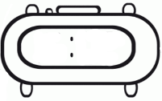

PORTUGUÊS *on-line*

COMPLETE A CRUZADINHA COM AS PALAVRAS ABAIXO.

**CAFETEIRA – BULE – PENEIRA – XÍCARA – CHALEIRA – CAFÉ – COADOR**

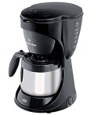

**TÉRMINO:**



|  |  |  |  |  |  |  |  |  |  |  |  |
| --- | --- | --- | --- | --- | --- | --- | --- | --- | --- | --- | --- |
|  | http://www.regitronic.com.br/config/imagens_conteudo/produtos/imagensGRD/GRD_1727_chaleira.jpghttp://coffeetraveler.net/wp-content/photos/orig_CoadorCafe.jpg | | |  |  |  |  |  |  |  |  |
|  |  | | |  |  |  |  |  |  |  |  |
| http://betobizza.blog.uol.com.br/images/bule.jpg | |  | |  |  |  |  |  |  |  |  |
|  | |  | |  |  |  |  |  |  |  |  |
|  |  | | |  |  |  |  |  |  |  |
|  |  | |  |  |  |  |  |  |  |  |
|  |  | |  |  |  |  |  |  |  |  |
| http://2.bp.blogspot.com/-phztRCDyy8w/TdA_JnYYb1I/AAAAAAAAAB0/JEywEF25fNc/s1600/65_cafe-xicara-grande.jpg |  | |  |  |  |  |  |  |  |  |
|  |  | | http://paulomarx.files.wordpress.com/2008/09/.jpg |  |  |  |  |  |  |  |