english

1. Observe os personagens abaixo. Quais são as profissões deles? Ligue as palavras às imagens.
BAKER MODEL FASHION DESIGNER TEACHER
JOURNALIST MUSICIAN MAYOR ASSISTANT BODYGUARD
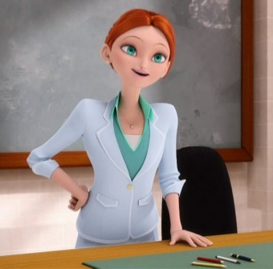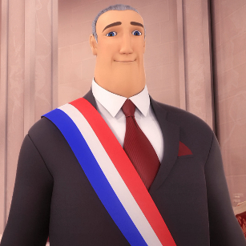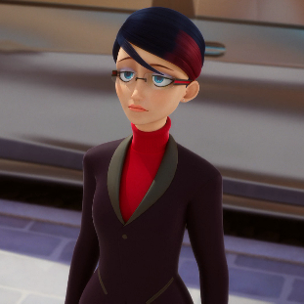
Ms. Bustier Andre Bourgeois Nathalie Sancoeur
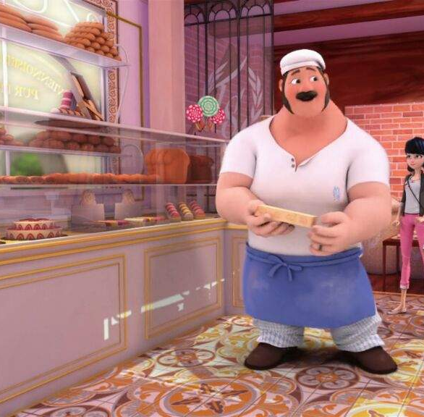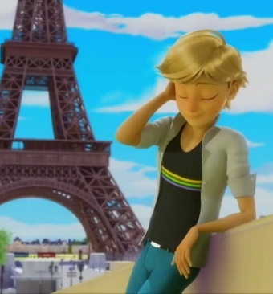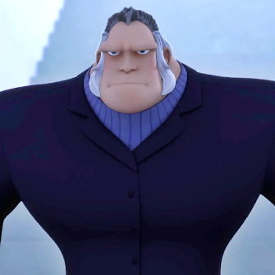
Tom Dupain Adrien Agreste “the Gorilla”
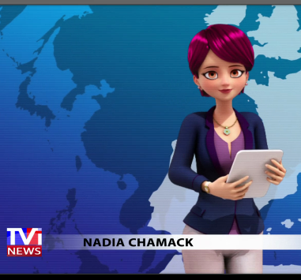
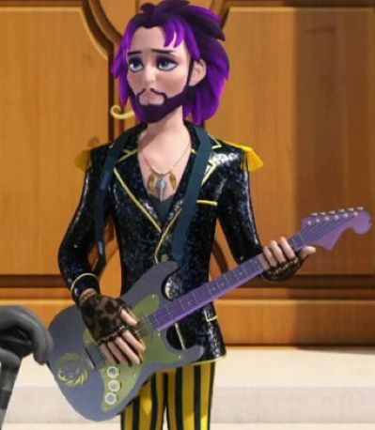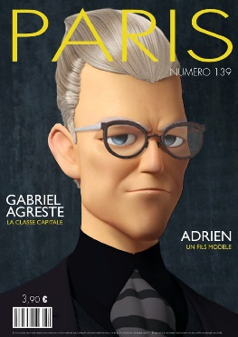
Jagged Stone Gabriel Agreste Nadia Chamack

2. Agora, forme frases com as palavras da atividade anterior. Escreva uma frase sobre cada personagem e sua profissão.

Veja o exemplo: Ms. Bustier is a teacher.

____________________________ is a _ ____________________________________________.
______________________________________________________________________________.
______________________________________________________________________________.
______________________________________________________________________________.
______________________________________________________________________________.
______________________________________________________________________________.
______________________________________________________________________________.
______________________________________________________________________________.

