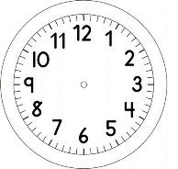

INÍCIO:

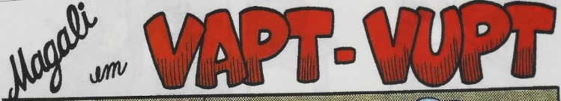
PORTUGUÊS

- OBSERVE OS QUADRINHOS E NUMERE-OS DE ACORDO COM A SEQUÊNCIA DOS ACONTECIMENTOS DA HISTÓRIA.
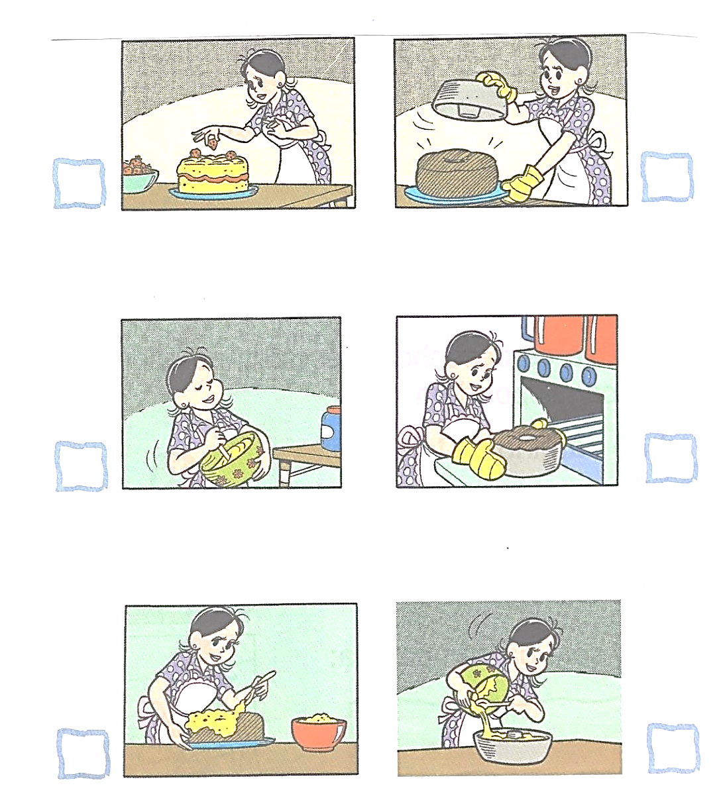

- AGORA, ESCREVA UMA IDEIA QUE REPRESENTE A IMAGEM.

________________________________________________________________________________________________________________________________

________________________________________________________________________________________________________________________________

________________________________________________________________________________________________________________________________

________________________________________________________________________________________________________________________________

________________________________________________________________________________________________________________________________

________________________________________________________________________________________________________________________________

