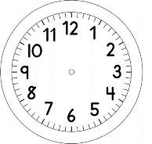

INÍCIO:

PORTUGUÊS - ON-LINE
CALIGRAFIA

_________________________________________________________________________________________________

_________________________________________________________________________________________________

_________________________________________________________________________________________________

_________________________________________________________________________________________________

_________________________________________________________________________________________________

_________________________________________________________________________________________________

_________________________________________________________________________________________________

_________________________________________________________________________________________________

_________________________________________________________________________________________________

