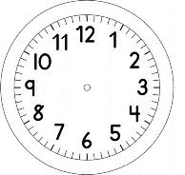

INÍCIO:

PORTUGUÊS
BRUXINHA ZUZU
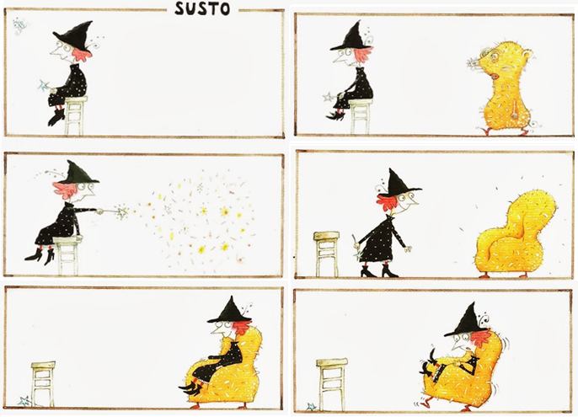
BRUXINHA ZUZU - EVA FURNARI

OBSERVE AS ILUSTRAÇÕES ACIMA E ESCREVA UMA HISTÓRIA PARA ELA.
COMECE CONTANDO QUEM É A BRUXINHA, E DEPOIS ESCREVA O QUE ACONTECE COM ELA DURANTE A HISTÓRIA. POR FIM, DÊ UM FINAL CRIATIVO.

________________________________________________________________________________________________________________________________________________________________________________________________________________________________________________________________________________________________________________________________________________________________________________________________________________________________________________________________________________________________________________________________________________________________________________________________________________________________________________________________________________________________________________________________________________________________________________________________________________________________________________________________________________________________________________________________________________________________________________________________________________________________________________________________________________________________________________________________________________________________________________________________________________________________________________________________________________________________________________________________________________________________________________________________________________________________________________________________________________________________________________________________________________________________________________________________________________________________________________________________________________________________________________________________________

