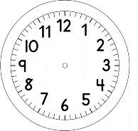

INÍCIO:

PORTUGUÊS – ON-LINE
CALIGRAFIA
____________________________________________________________________________
___________________________________________________________________________
___________________________________________________________________________

_____________________________________________________________________________
_____________________________________________________________________________
_____________________________________________________________________________

