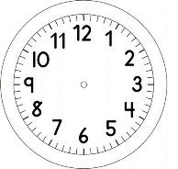
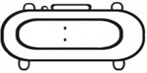

INÍCIO:

PORTUGUÊS
QUESTÃO 1
CIRCULE A PALAVRA QUE ESTÁ ESCRITA CORRETAMENTE.
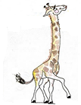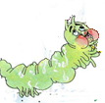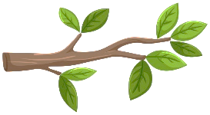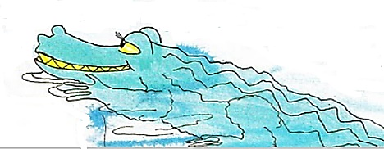
JACARÉ
GACARÉ
JAGARÉ

GALO
GALIO
GALHO

MED-PAUMO
MDPLMO
MEDE-PALMO

GIRRAFA
GIRAFA
GIAFA

GIRRAFA
GIRAFA
GIAFA

GIRRAFA
GIRAFA
GIAFA

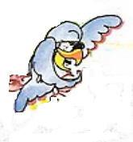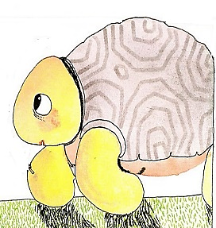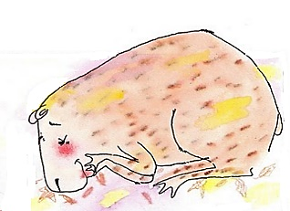
GAPIVARA
CAPIVARA
CAPIVARRA

GABUTI
JABUD
JABUTI

PAPAGAIO
PAPGAO
PAPACAIO

LAGIMA
LÁGRIMA
LACRIMA

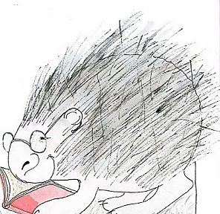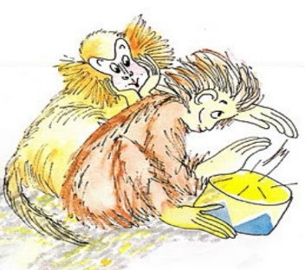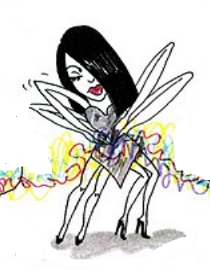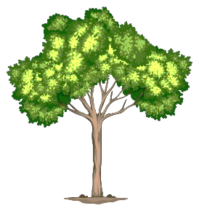
ARRANHA
ARNA
ARANHA

ÁRVORRE
ÁRVORE
AVORE

MCAC
MACACOS
MAKACO

PORCO-ESPINHO
POCO ESPINO
PCO EPO

QUESTÃO 2
OPA! AS PALAVRAS SE JUNTARAM.
SEPARE AS PALAVRAS E ESCREVA A FRASE NOVAMENTE.

BENEDITABATEUNUMAÁRVOREEFICOUPRESAEMSEUSGALHOS.
____________________________________________________________________________________________________________________________________________________________________________________

OMEDE-PALMOAJUDOUAGIRAFABENEDITA.
____________________________________________________________________________________________________________________________________________________________________________________

LOGOADIANTEENCONTROUOJABUTI.
____________________________________________________________________________________________________________________________________________________________________________________

BENEDITADESENCALHADA,SAIUPULANDODEALEGRIA.
____________________________________________________________________________________________________________________________________________________________________________________

EOMEDE-PALMOORGULHOSOFOIEMBORANOSEUPASSOCOMPASSADO.
____________________________________________________________________________________________________________________________________________________________________________________

