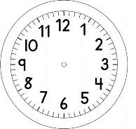
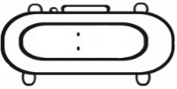

INÍCIO:

PORTUGUÊS: Frases
QUESTÃO 1
ESCREVA UMA FRASE PARA CADA FIGURA QUE ESTÁ ABAIXO. SEJA CRIATIVO!



