online lessons – lvii

1. Ouça a música a seguir, Love is a Beautiful Thing, e preencha as lacunas com as palavras que faltam.
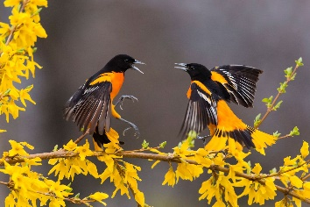
https://www.youtube.com/watch?v=SD3GrPgqSZ0

Love is a beautiful thing BIRDS
Hugging, kissing, laughing, holding hands
Love is a beautiful thing
Unless it's you loving another man
And I can't stand to see you hugging
Kissing, laughing, holding _________
If it's not me, you see AUTUMN
How could that be a thing of beauty?
Love is a beautiful thing
________ are singing songs down from the ________
Love is a beautiful thing FEET
The breeze is blowing, rustling _________ leaves
But if those __________ are rustling
Underneath somebody else's _________
If it's not me, you see, then
How could that be a thing of beauty?
HANDS
I find comfort in believing
Over time I'll come to see someday
How love could be that way

Love is a beautiful thing
________'s rage has softened into _________ SPRING
Love is a beautiful thing
And on your hand I see that there's a ring
And I would understand if I had put that ring upon your hand
But it was not me, you see, how could that be a thing of beauty?
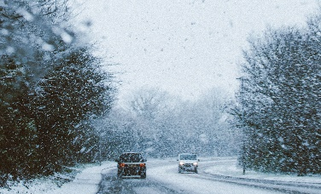
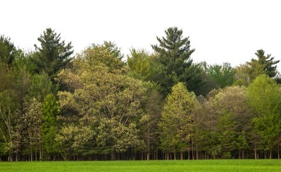

TREES LEAVES WINTER

