Matemática
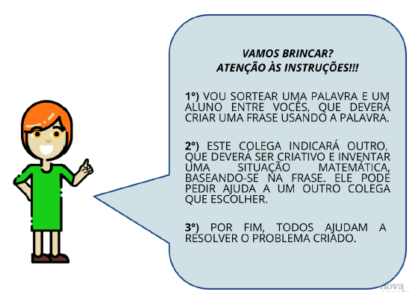
Problema:
________________________________________________________________________________________________________________________________________________________________________________________________________________________________________________________________________________________________________________________________________________________________________________________________________________________________________________________________________________________________________________________________________________________________________________________________________________________________________________________________________________________________________________________________________________________________________________________________________________________________________________________________________________________________________________________________________________________________________________________________________________________________________________________________________________________________________________________________________________________________________________________________

R: ________________________________________________________________________
__________________________________________________________________________
__________________________________________________________________________
__________________________________________________________________________
__________________________________________________________________________

