português – Especial de natal
Pensando em todas as atividades realizadas sobre o Natal durante a semana, produza um texto sobre o Natal. Conte tudo que aprendeu: fale sobre os símbolos natalinos, sobre as tradições, comemorações etc. Fale também como é comemorado o Natal em sua casa.
____________________________________________________________________________________________________________________________________________________________________________________________________________________________________________________________________________________
____________________________________________________________________________________________________________________________________________________________________________________________________________________________________________________________________________________
____________________________________________________________________________________________________________________________________________________________________________________________________________________________________________________________________________________
________________________________________________________________________________________________________________________________________________________________________________________________________________________________________________________________________________________________________________________________________________________________________________________________________________________________________________________________________________________________________________________________________________________________________
_________________________________________________________________________________________________________________________________________________________________________________________________________________________________________________________________________________________________________________________________________________________
____________________________________________________________________________________________________________________________________________________________________________________________________________________________________________________________________________________

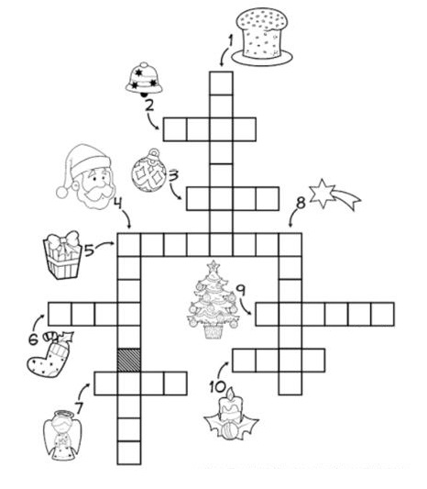
2. Resolva a cruzadinha:

3.Encontre no caça-palavras as palavras abaixo:

Presépio árvore estrela cartões anjos Papai Noel
natal velas presentes sinos ceia bolas coloridas
guirlanda
