português – tirinhas e onomatopeias
- Observe as tirinhas e responda:
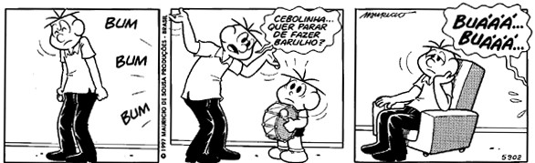

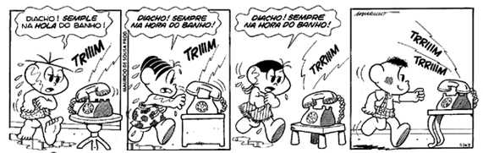

O que você observou em comum entre elas? Escreva com as suas palavras.
______________________________________________________________________________________________________________________________________________________________________________________________________________________________________________________________________________________________________________________________________________________________________________________________________________________________

- Identifique as onomatopeias de cada quadrinho. Copie-as e escreva o som ou ruído que elas representam.
___________________________________________________________________________________________________________________________________________________________________________________________________________________________________________________________________________________________________________________________________________________________________________________________________________________________________________________________________________________________________

