português
- Identifique e sublinhe as onomatopeias encontradas nas tirinhas a seguir. Feito isso, escreva o som que cada uma delas representa.
Exemplo: ding dong = som de campainha tocando.
Tirinha 1
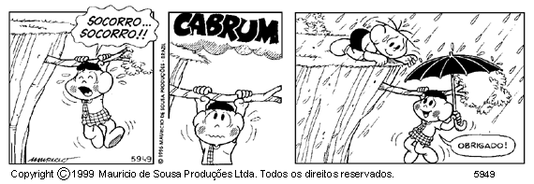

Tirinha 2

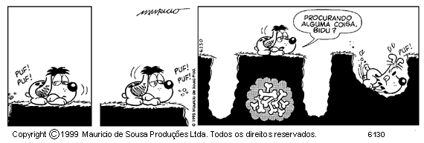

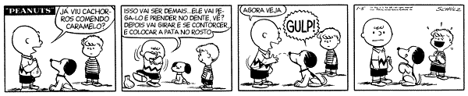
Tirinha 3

Tirinha 4
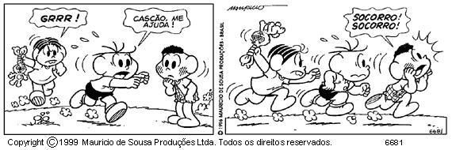

Tirinha 5

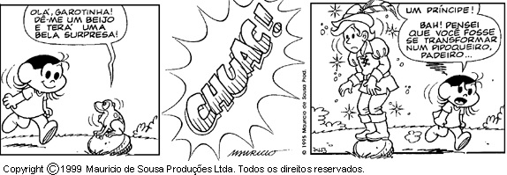

___________________________________________________________________________________________________________________________________________________________________________________________________________________________________________________________________________________________________________________________________________________________________________________________________________________________________________________________________________________________________________________________________________________________________________________________________________________________________________________________________________________________________________________________________________________________________________________________________________________________________________________________________________________________________________________________________________________
- Leia os quadrinhos abaixo, identifique e transcreva as onomatopeias e intejeições encontradas. Em seguida, escreva o significado de cada uma delas classificando-as.
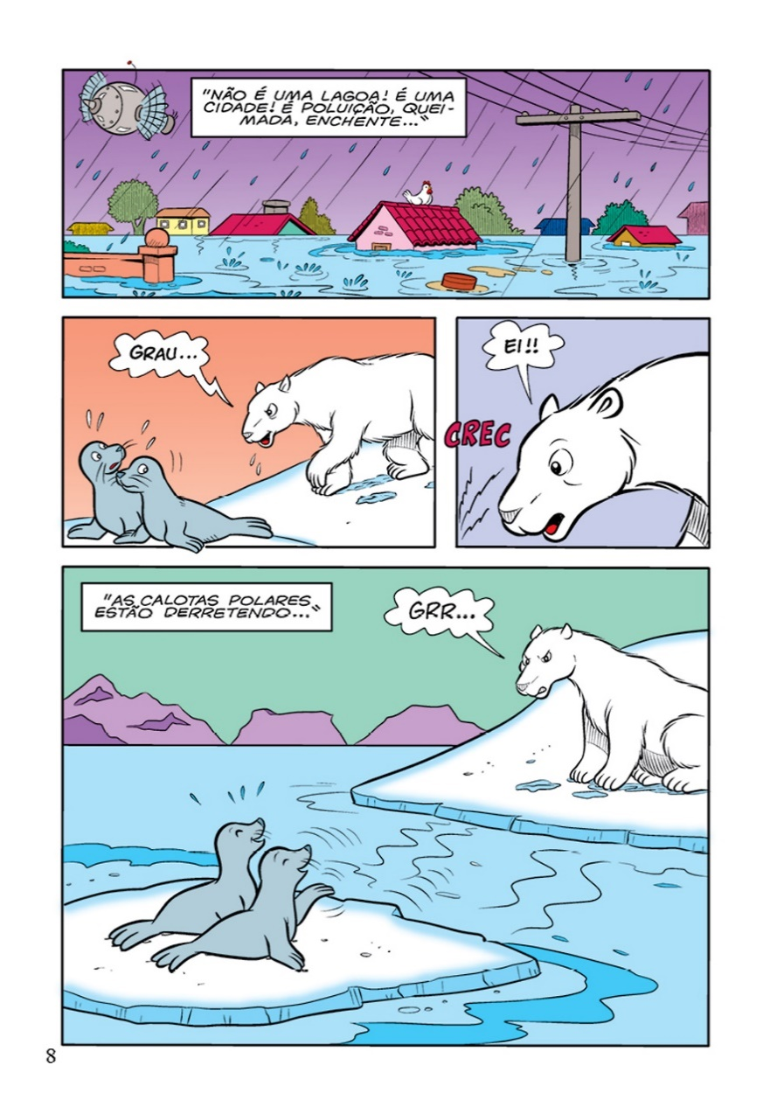
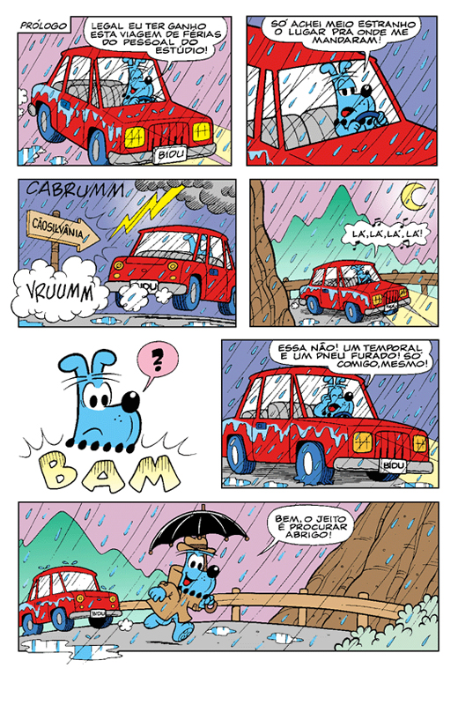

_____________________________________________________________________________________________________________________________________________________________________________________________________________________________________________________________________________________________________________________________________________________________________________________________________________________________________________________________________________________
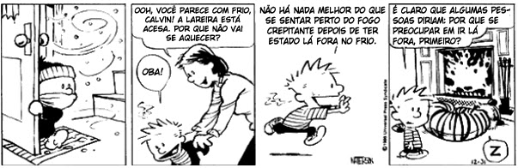
- Identifique e circule as interjeições da tirinha abaixo:

_______________________________________________________________________________________________________________________________________________________________________________________________________________________________________________________________________________________________________________________________________________

