english class iii
KET

1. Read the text and answer the questions:

The Rorschach Test
The Rorschach test is a psychological test.
Psychologists apply this test by presenting symmetric inkblots to patients.
Patients describe what they see to psychologists.
Then, they examine the patients’ personality characteristics and emotional functioning.

2. Pesquise e registre a definição das palavras sublinhadas.

3. Take the test! What do you see in each picture? Describe it:

__________________________________________
__________________________________________
__________________________________________

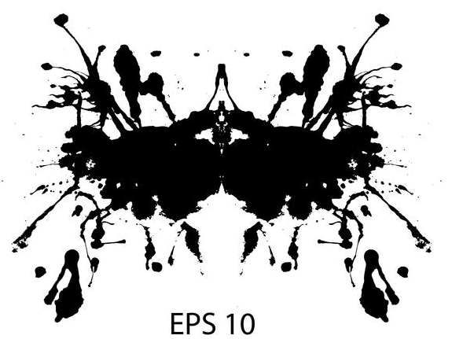

__________________________________________
__________________________________________
__________________________________________

__________________________________________
__________________________________________
__________________________________________

6. BONUS: Crie seu próprio teste. Dobre uma folha de papel ao meio com tinta e deixe a figura se formar. Abra o papel e envie uma foto do resultado para teacherjulia.ieijf2@gmail.com !

