Instituto de Educação Infantil e Juvenil

Outono, 2020. Londrina, 26 de Março.

Nome: ____________________________________ Turma: ____________

Área do conhecimento: Inglês | Professor(a): Leandro

English Individual Progress A1

A) Watch the video using this link https://eslvideo.com/quiz.php?id=34640 or the QR code and answer the questions below (you may use the dictionary):
1. What does the man receive in the mail?
a.) No, it´s raining
b.) English for Beginners books and CDs.
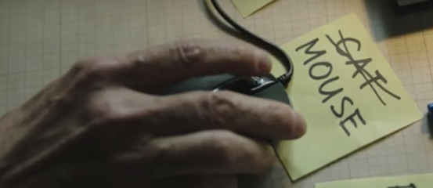
2. What does he make in the kitchen?
a.) a sandwich
b.) some coffee or tea.
3. Who does he study with?
a.) at the desk
b.) his dog.
4.) What does he say on the bus?
a.) I love you.
b.) Can you show me the way to the beach
5.) What does he receive in the mail?
a.) a suitcase
b.) slippers, toothbrush, passport and pajamas
B) Do the same as the man in the video: prepare 10 slips of paper, with new object words and stick them around your house.
C) Do your self-evaluation of the day (D.P.O): _________

-I will be online during regular class time, you may contact me through:
leandro.ieijf2@gmail.com using e-mail, Hangouts. Post this document on Moodle!

