ENGLISH CLASS vii: CAN YOU SING?
KET

1. Crie frases sobre você usando CAN/CAN’T e as ações do quadro, conforme os exemplos:
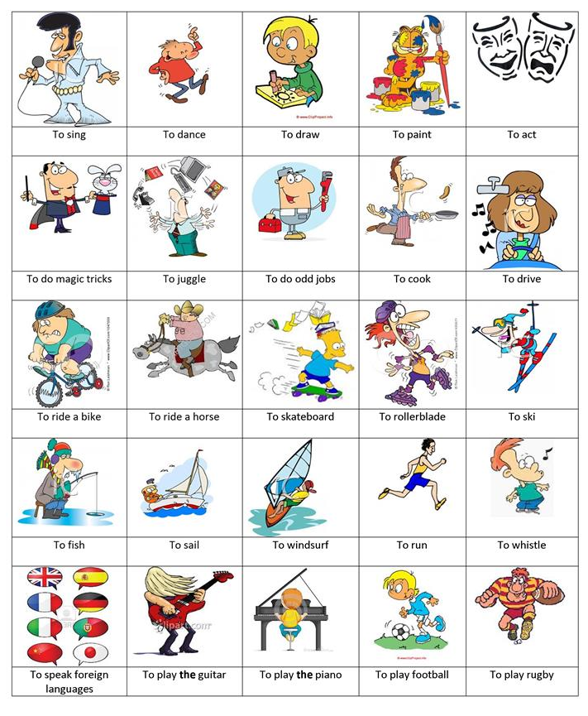
Examples: I can sing. I can’t act.
I can play the piano. I can’t play the guitar.
_______________________________________________________________________________
_______________________________________________________________________________
_______________________________________________________________________________
_______________________________________________________________________________
_______________________________________________________________________________
_______________________________________________________________________________
_______________________________________________________________________________
_______________________________________________________________________________
_______________________________________________________________________________
_______________________________________________________________________________
_______________________________________________________________________________
_______________________________________________________________________________
_______________________________________________________________________________
_______________________________________________________________________________
_______________________________________________________________________________
_______________________________________________________________________________
_______________________________________________________________________________
_______________________________________________________________________________
_______________________________________________________________________________
_______________________________________________________________________________
_______________________________________________________________________________
_______________________________________________________________________________
_______________________________________________________________________________
_______________________________________________________________________________
_______________________________________________________________________________
_______________________________________________________________________________
_______________________________________________________________________________
_______________________________________________________________________________
_______________________________________________________________________________
_______________________________________________________________________________

