ENGLISH CLASS vii: fact or fiction?
PET

1. Humans from our generations are probably the ones with the most access to information in history, and also the ones with the most communication tools. The internet gives everybody a place to speak. The problem is many people are not careful enough to distinguish if what others say are facts or simply their opinion…
Do you think you can make that distinction? Read the text below and categorize the underlined sentences as “facts” or “opinions”.

This is What Now Looks Like

What do you do when yesterday, today and tomorrow becomes only now?
Posted Mar 21, 2020
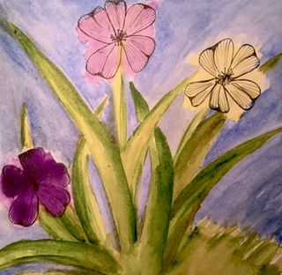
Yesterday is different from Today and also from Tomorrow.
Source: cjknowles
The first time I saw a Yesterday, Today and Tomorrow bush, or Brunfelsia latifolia, I was dazzled.
It seemed to have everything, a beautiful fragrant form and flat two-inch flowers that not only bloomed in abundance, but magically changed colors.
Each of the flowers lasts for three days. On the first day, the bloom is deep purple; the second day the bloom turns a pastel lavender; and on the third, a creamy white. Hence, they are called Yesterday, Today and Tomorrow.
In any given moment, from early spring through October, these plants are covered with hundreds of deep purple, lavender and white blossoms creating an extravagant bouquet. And, although individual blossoms are constantly blooming, changing, then dying, there are always new blossoms opening and promising to change.
Change. That’s the key to its beauty.
All seductive and beautiful things should come with a warning, and the Yesterday, Today and Tomorrow is no exception. The plant contains poisonous alkaloids, the seeds from the flowers are poisonous, and berries are especially toxic.
There’s a lesson there. And here we are, caught in the now of life.
Today might be the first day for some being quarantined. For others, it’s their second, third or fourth day. Some are even two- week veterans. Everyone on the internet is talking about the “new” normal.
Ask anyone who has experienced a personal loss, and they will tell you that the “new” normal is a big pill to swallow. There’s only yesterday to lean on. Today is a tough row to hoe, and tomorrow looms like a terrifying dark empty cavern.
I love that so many museums, theatre venues, educational resources, and just plain fun entertaining things like a virtual walk through National Parks have become available in an internet outpouring of things to watch and do. But it’s not as easy as some might imagine pushing our life of busy-ness aside and leaning into the luxury of doing nothing.
And, wait, is that really how you are supposed to embrace living in the now, the new normal? Whatever that is?
Here’s the thing. I can’t tell you what to do or how to spend your time being quarantined and neither can anyone else. That’s the lesson of living in the now. It’s only about you.
Surprise! This little “stay-cation” is not exactly what we thought it was going to be. It’s not business as usual. And in the shift from yesterday to today, we need to suspend planning for tomorrow.
Today is just today. It will be what you want it to be. It is now. Just now. It’s not what you did or who you were yesterday or what you think you’re going to do tomorrow. It’s right now. This is your chance to shut out all the voices in the world telling you what you should do.
The only task at hand is learning how to live in that one beautiful moment only you have today. Make it a kind moment. Make it a personal moment. Make it a moment to share some time with your family either in person on or on the phone.
Make it a good one.

FACTS | OPINIONS

