Instituto de Educação Infantil e Juvenil

Outono, 2020. Londrina, 27 de Abril.

Nome: ____________________________________ Turma: ____________

Área do conhecimento: Inglês | Professor: Leandro

English Individual Progress_A1

Be welcome! Resuming our studies, together we will work hard to evolve in English so that by July many will reach the international certificate, in addition to being able to watch films, series, listening to music and read books in English and as soon as you have an opportunity, travel around as a citizen of the world.
- Study for 30 min (no histórico do estudante) using Dyned.
- Self-coaching Open - “Opções - Relatório detalhado” and analise it.
- Write a short text about THIS DYNED SESSION (at least 2 lines – IN ENGLISH)!
- Do the self-evaluation of the day (D.P.O)
- Write the answers on Moodle (texto online)! (abaixo é o exemplo, escreva no Moodle)
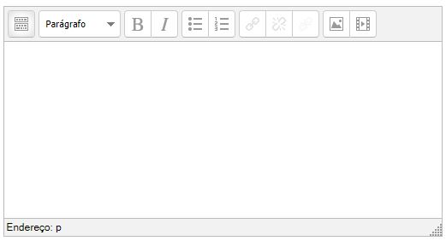
-I will be online during regular class time, you may contact me through:
leandro.ieijf2@gmail.com using e-mail or Hangouts.

