Instituto de Educação Infantil e Juvenil

Outono, 2020. Londrina, 30 de Abril.

Nome: ____________________________________ Turma: ____________

Área do conhecimento: Inglês | Professor: Leandro

VOA English – LESSON 2 and 3

- Watch the video on this website Level 1 Lesson 2 and 3:
Lesson 2 https://learningenglish.voanews.com/a/lets-learn-english-lesson-2-hello/3113733.html
Lesson 3 https://learningenglish.voanews.com/a/lets-learn-english-lesson-3-i-am-here/3126527.html
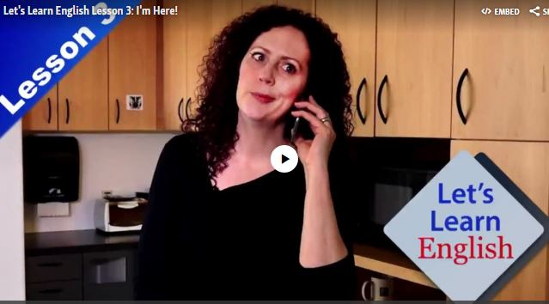
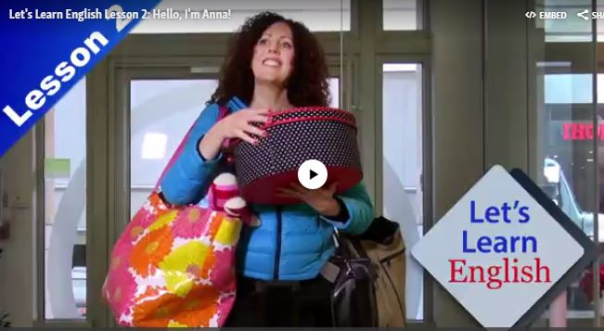

- Study these words.
Key Words
cook - v. to prepare (food) for eating especially by using heat
dinner - n. the main meal of the day
excuse - v. to forgive someone for making a mistake or doing something wrong
find - v. to get or discover something or someone that you are looking for
here - adv. in this place or at this location
live - v. to have a home in a specified place
near - adv. close to something or someone
number – n. a number or a set of numbers and other symbols that is used to identify a person or thing or a telephone number
sorry - adj. feeling sorrow or regret
supermarket - n. a store where customers can buy a variety of foods and household items
there - adv. in that place or at that location
want - v. to desire or wish for something
wrong - adj. not suitable or appropriate for a particular purpose, situation, or person

- Do the exercises Listening Quizzes (Lesson 2 and 3) at the bottom of the web pages.
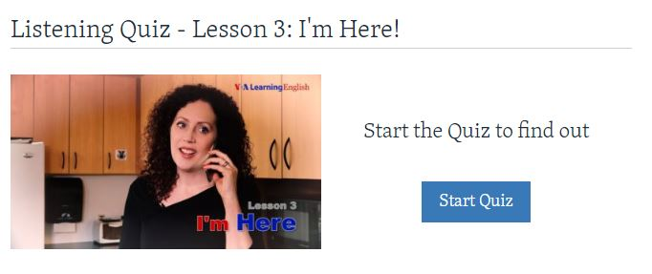

- Do your self-evaluation(D.P.O): _________

- Write these answers on Moodle or post this document!

- REMEMBER 1HOUR AND 30 MINUTES OF DYNED PER WEEK IN THE MINIMUN.

-I will be online during regular class time, you may contact me through:
leandro.ieijf2@gmail.com using e-mail, Hangouts.

