Instituto de Educação Infantil e Juvenil

Outono, 2020. Londrina, 30 de Abril.

Nome: ____________________________________ Turma: ____________

Área do conhecimento: Inglês | Professor: Leandro

VOA English – LESSON 2 and 3

- Watch the video on these webpages Level 2 Lesson 2 and 3:
Lesson 2 https://learningenglish.voanews.com/a/lets-learn-english-level-2-lesson-2/3960471.html
Lesson 3 https://learningenglish.voanews.com/a/lets-learn-english-level-2-lesson-3/4027340.html

- Study these new words and incorporate to your own vocabulary.

find out - phrasal verb. to learn (something) by making an effort
give out - phrasal verb. to give (something) to many people or to hand out (something)
go back to - phrasal verb. to return to a person, place, subject, or activity
take on - phrasal verb. to begin to deal with (something, such as a job or responsibility)
team up- phrasal verb. to join with someone to work together
tear up - phrasal verb. to completely destroy (something) by tearing it into pieces
throw away - phrasal verb. to put (something that is no longer useful or wanted) in a trash can, garbage can, rubbish bin
cabin - n. a small, simple house made of wood
cheery - adj. having or causing happy feelings
crossword puzzle - n. a puzzle in which words that are the answers to clues are written into a pattern of numbered squares that go across and down
grumpy - adj. easily annoyed or angered, having a bad temper or complaining often
helicopter - n. an aircraft that can stay in the air without moving forward and that has metal blades that turn around on its top
host - v. to talk to guests on a television or radio show
offer -n. the act of giving someone the opportunity to accept something
lock - v. to fasten (something) with a lock
people person - n. a person who enjoys or is particularly good at interacting with others
personal skills - n. (interpersonal skills) the skills used by a person to interact with others properly
team player - n. someone who cares more about helping a group or team to succeed than about his or her individual success
want ad - n. a notice in a newspaper, magazine, or website that lets people know about something that you want to buy or sell or a job that is available
wish me luck - expression. asks someone to say that they hope you will have success commute - v. to travel regularly to and from a place and especially between where you live and where you work
consultant - n. a person who gives professional advice or services to companies for a fee
event- n. something (especially something important or notable) that happens
exactly - adv. used to stress that something is accurate, complete, or correct
hug - v. to put your arms around someone especially as a way of showing love or friendship
point of view - n. a way of looking at or thinking about something
pond - n. an area of water that is surrounded by land and that is smaller than a lake
promise - v. to tell someone that you will definitely do something or that something will definitely happen in the future
scooter - n. a child's vehicle that is made of a narrow board with two small wheels attached
waste - v. to use (something valuable) in a way that is not necessary or effective

- Write a text describing what happened in the videos of Lesson 2 and 3. (50 words – minimum)

- Do the Quizzes online on the bottom of the page.
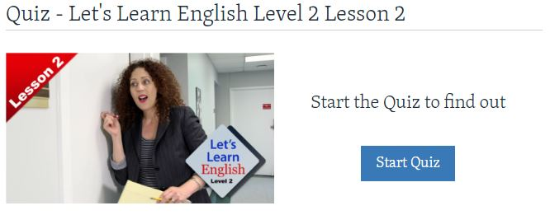
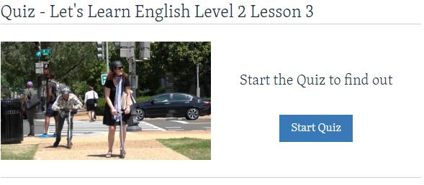
- Do your self-evaluation (D.P.O): _________
- Write these answers on Moodle or post this document on Moodle!
- REMEMBER 1 HOUR AND 30 MINUTES OF DYNED PER WEEK IS THE MINIMUM.
-I will be online during regular class time, you may contact me through:
leandro.ieijf2@gmail.com using e-mail, Hangouts.

