english class iii
KET
Início: Término: DPO:

Good morning!
Today, we are going to compare FACTS and OPINIONS.

I. Can you tell the difference?
Para cada comentário (1 a 10) abaixo sobre obras de arte, identifique se nele constam fatos, opiniões ou ambos. Para as outras perguntas, siga a instrução do enunciado.

1. "This painting is so beautiful. I love the colours."
[ ] FACT [ ] OPINION [ ] BOTH

2. "This picture makes me sad."
[ ] FACT [ ] OPINION [ ] BOTH

3. "The artist used many warm colours in this painting."
[ ] FACT [ ] OPINION [ ] BOTH

4. "There are green fields and birds."
[ ] FACT [ ] OPINION [ ] BOTH

5. "There is a beautiful night sky and a scary house."
[ ] FACT [ ] OPINION [ ] BOTH

6. "There are some kids laughing and playing."
[ ] FACT [ ] OPINION [ ] BOTH

7. "This painting is very dark, very somber…”
[ ] FACT [ ] OPINION [ ] BOTH

8. "I love this. It's so peaceful."
[ ] FACT [ ] OPINION [ ] BOTH

9. "They look young and happy."
[ ] FACT [ ] OPINION [ ] BOTH

10. "She looks angry to me."
[ ] FACT [ ] OPINION [ ] BOTH

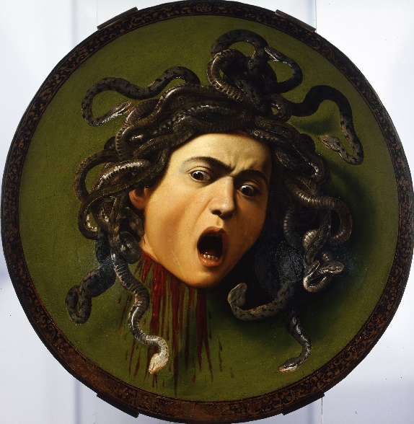
11. State a FACT about the Caravaggio painting:

12. Give your OPINION about the Caravaggio painting:

