english class iv
KET
Início: Término: DPO:

1. Go to https://www.google.com/search?q=jogos+conhecidos+do+Google+Doodle&oi=ddle&ct=153499117&hl=pt-BR&source=doodle-ntp&ved=0ahUKEwiAg6Du2KLpAhXZG7kGHfAaBLEQPQgB
and play the Google Doodle Lotería FIVE TIMES.

2. Answer the questions:
a) Where is the game from? ________________________________________________
b) How many times did you win? ________________________________________________
c) How many times did you lose? ________________________________________________
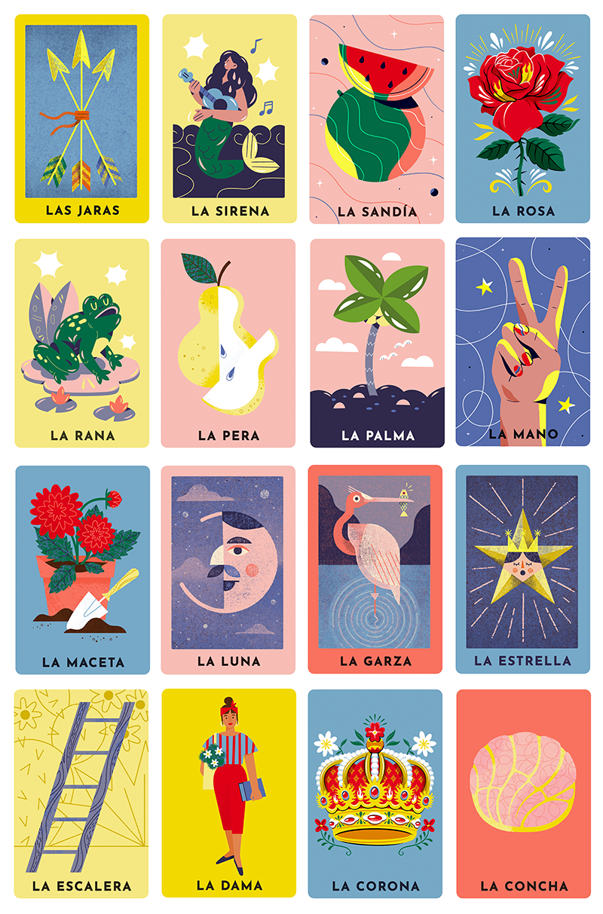
3. Look at the Lotería board and choose 4 cards. Describe those cards.
___________________________________
___________________________________
___________________________________
___________________________________
___________________________________
___________________________________
___________________________________
___________________________________
___________________________________
___________________________________
___________________________________
___________________________________
___________________________________
___________________________________
___________________________________

