english class v

Good morning!
Após terminar seu tempo de DynEd (30min), tente resolver a charada abaixo!
Não se esqueça de justificar sua resposta.

THE CELL
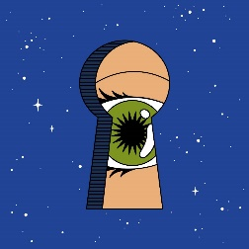
A prisoner has to choose which cell he’s going to serve his sentence inside.
The first cell is filled with fire and lava. The second cell is filled with angry bears, snakes and scorpions.
The third cell is filled with lions that haven’t eaten in years.
Which cell should he choose?

