english class v
KET
Início: Término: DPO:
37.0 million U.S. residents
Mexican Americans are Americans of full or partial Mexican descent. As of July 2018, Mexican Americans made up 11.3% of the United States' population, as 37.0 million U.S. residents identified as being of full or partial Mexican ancestry.

1. Read the text and answer the questions:

Cinco de Mayo is an annual celebration held on May 5. The date is observed to commemorate the ⁽¹⁾Mexican Army's victory over the ⁽²⁾French Empire at the Battle of Puebla, on May 5, 1862.
The victory of the smaller Mexican force against a larger French force was a boost to morale for the Mexicans.
More popularly celebrated in the United States than in Mexico, the date has become associated with the celebration of Mexican-American culture. These celebrations began in ⁽³⁾California, where they happen annually since 1863.
In Mexico, the commemoration of the battle continues to be mostly ceremonial, like ⁽⁴⁾military parades.
The city of Puebla marks the event with an arts festival, a festival of ⁽⁵⁾local cuisine, and re-enactments of the battle.
Cinco de Mayo is sometimes mistaken for Mexico's Independence Day — the most important national holiday in Mexico — which is celebrated on September 16.

I. Link the numbers in the text to the pictures below.
( ) 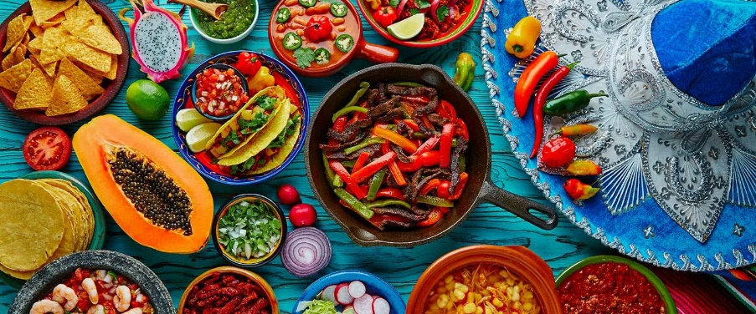
( ) 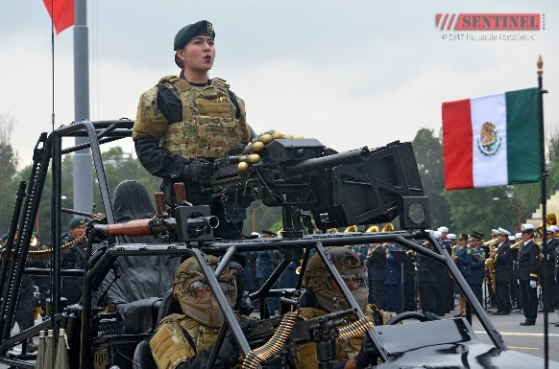 ( ) 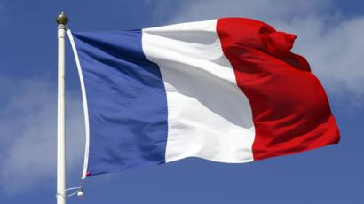

( ) 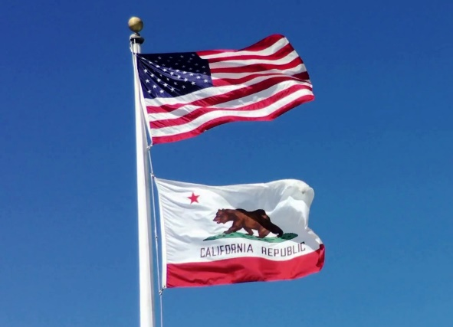 ( ) 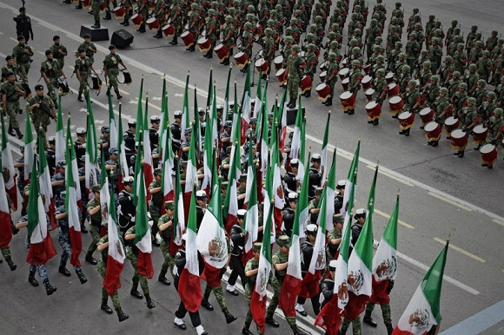

II. True or False?

( ) Cinco de Mayo is Mexico’s Independence Day.
( ) Mexico had a bigger army than France in the Battle of Puebla.
( ) Cinco de Mayo celebrations began in California.
( ) There is an arts and food festival in the city of Puebla on Cinco de Mayo.
( ) Cinco de Mayo is the most important holiday in Mexico.

III. Correct the false sentences:
________________________________________________________________________________
________________________________________________________________________________
________________________________________________________________________________

