english class v
Início: Término: DPO:

Good morning!

Last week, you played the Lotería and learned a little about its historical and cultural background.
Now, it’s time to get artsy and crafty! You are going to create your own set of Lotería cards!

Think about how the cards in the original Lotería represent Hispanic and Mexican culture: they show plants, objects, people and animals which are common or relevant in those countries.
For your customized cards, choose objects, plants, people or animals that represent YOU!
Games, books and clothes you like, people who are important to you (close to you or someone you admire), plants that decorate your house, fruits you like to eat, your pet(s)…
Express your personality through your work!

- Illustrate the cards on the next page (you can draw physically or digitally, or even use images from the internet and/or magazines to make a collage).
- On the bottom of the rectangle, write the name of the card. (See model)

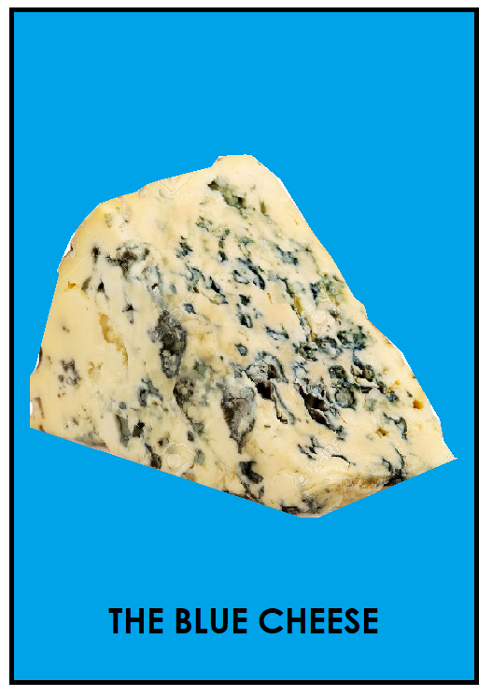
Model:
<- Teacher Julia’s Lotería card.

The model was made using Paint and a picture from the internet. The font used for the text was Century Gothic.

If everything goes well, we will soon play our own version of Lotería together!

