Instituto de Educação Infantil e Juvenil

Outono, 2020. Londrina, 14 de Maio.

Nome: ____________________________________ Turma: ____________

Área do conhecimento: Inglês | Professor: Leandro

REVIEW_A1+ to B2+

- Study all Quiz exercises of your level.
- Take notes of all the Grammar points of your level.
- Talk to the class for at least 3 min about your level, presenting the topics and contents.
- Look into all LEARNING POINTS in the extra material (sent to your e-mail) and check if you can communicate using all of them.
- Do the self-evaluation of the day (D.P.O)
6) Write down how is your English at this level, based on today's review (on Moodle!)
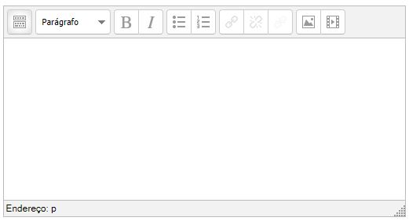

-I will be online during regular class time, you may contact me through:
leandro.ieijf2@gmail.com using e-mail or Hangouts.

