english class xi
KET

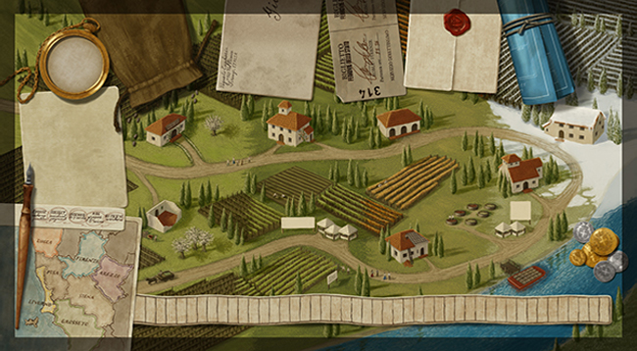
Go to the online meeting through the link below:
https://meet.google.com/iqk-dvon-ygh

