english class – xxv
Início: Término: DPO:

KET/PET
1. Look at the reinterpretations below. Artist Matheus Faria used scenes from Studio Ghibli’s films and turned them into representations of Brazilian culture.
What’s more impressive: he did it using Paint, which is an often undermined digital tool!
Do you know the stories he represented? Observe and think.

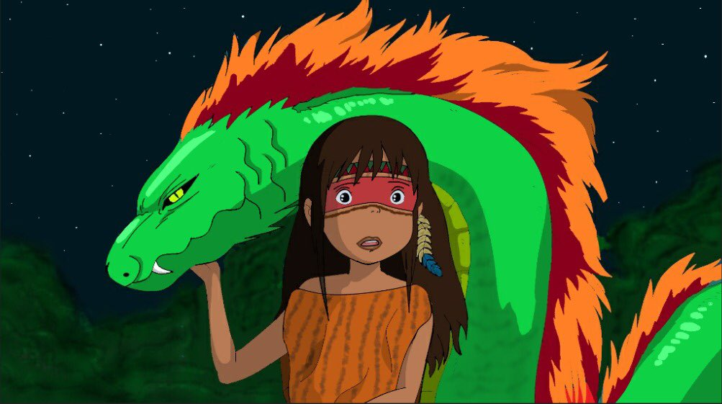

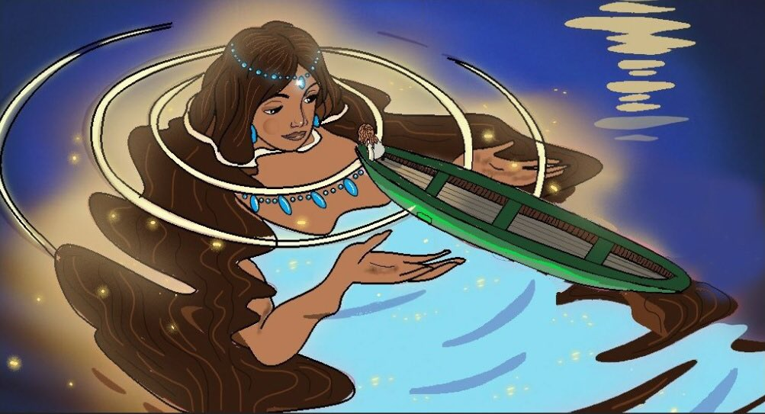
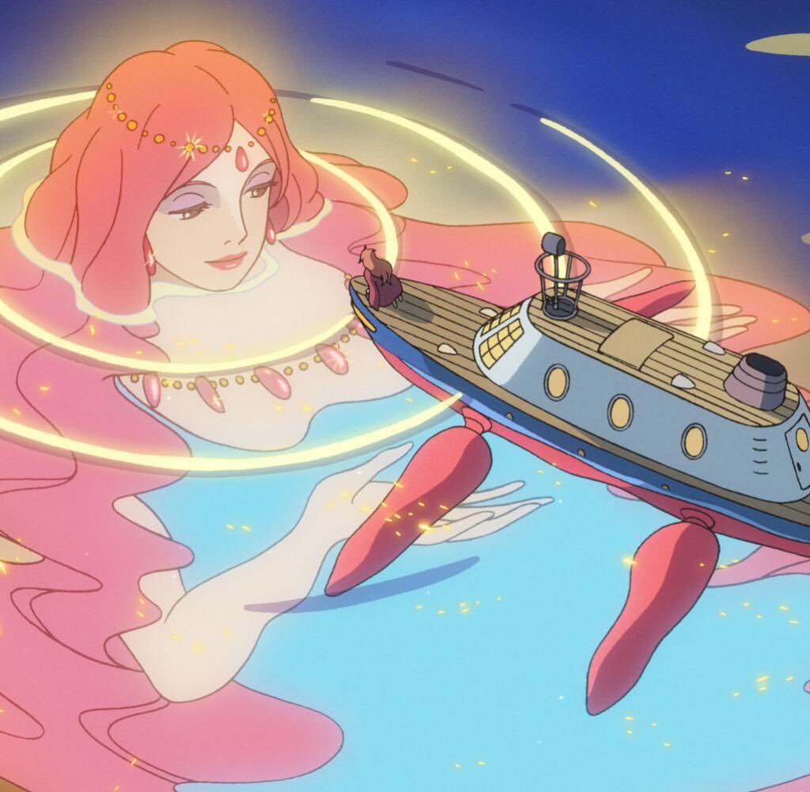

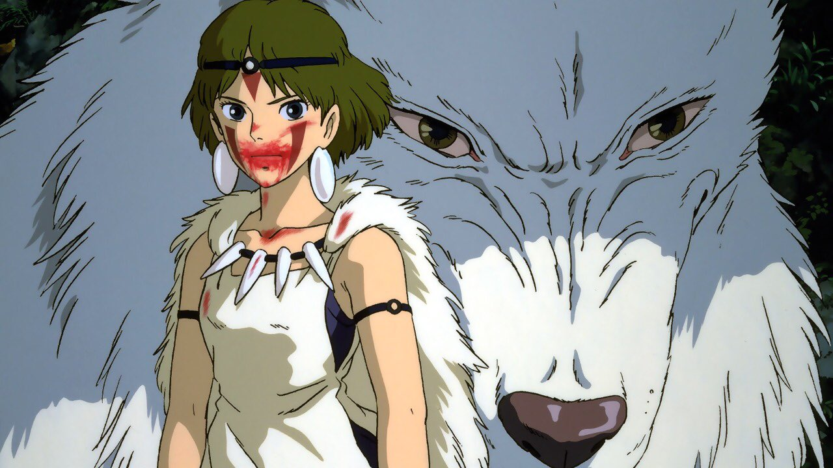
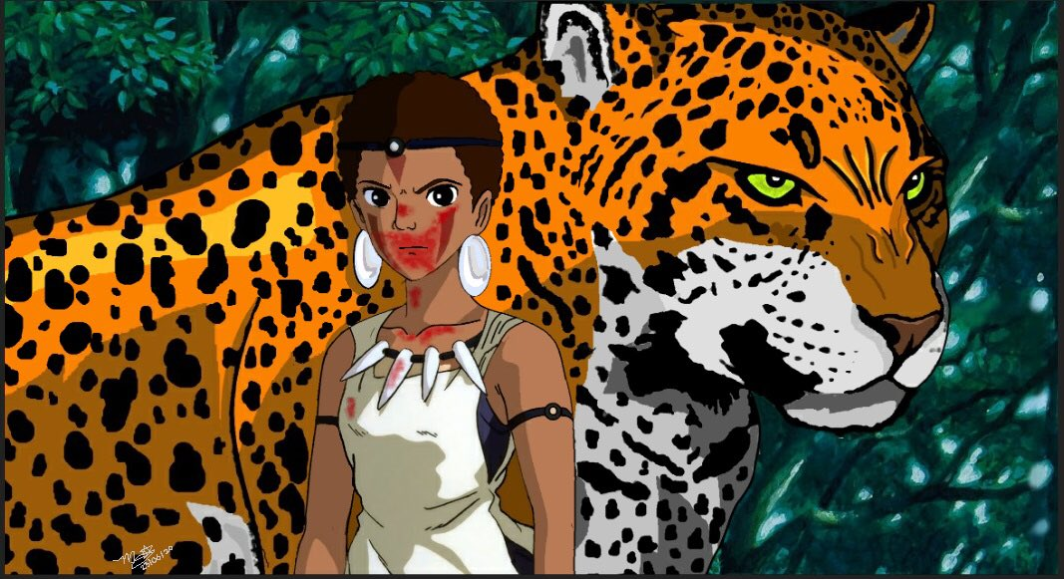
2. NOW IT’S YOUR TURN!
Choose a scene from a movie, cartoon, comic book (or any other media) that you like and turn it into a Brazilian scene. Something that represents our people, our story, our folklore…

Original:

Reinterpretation:

