english class xxvi
Início: Término: DPO:

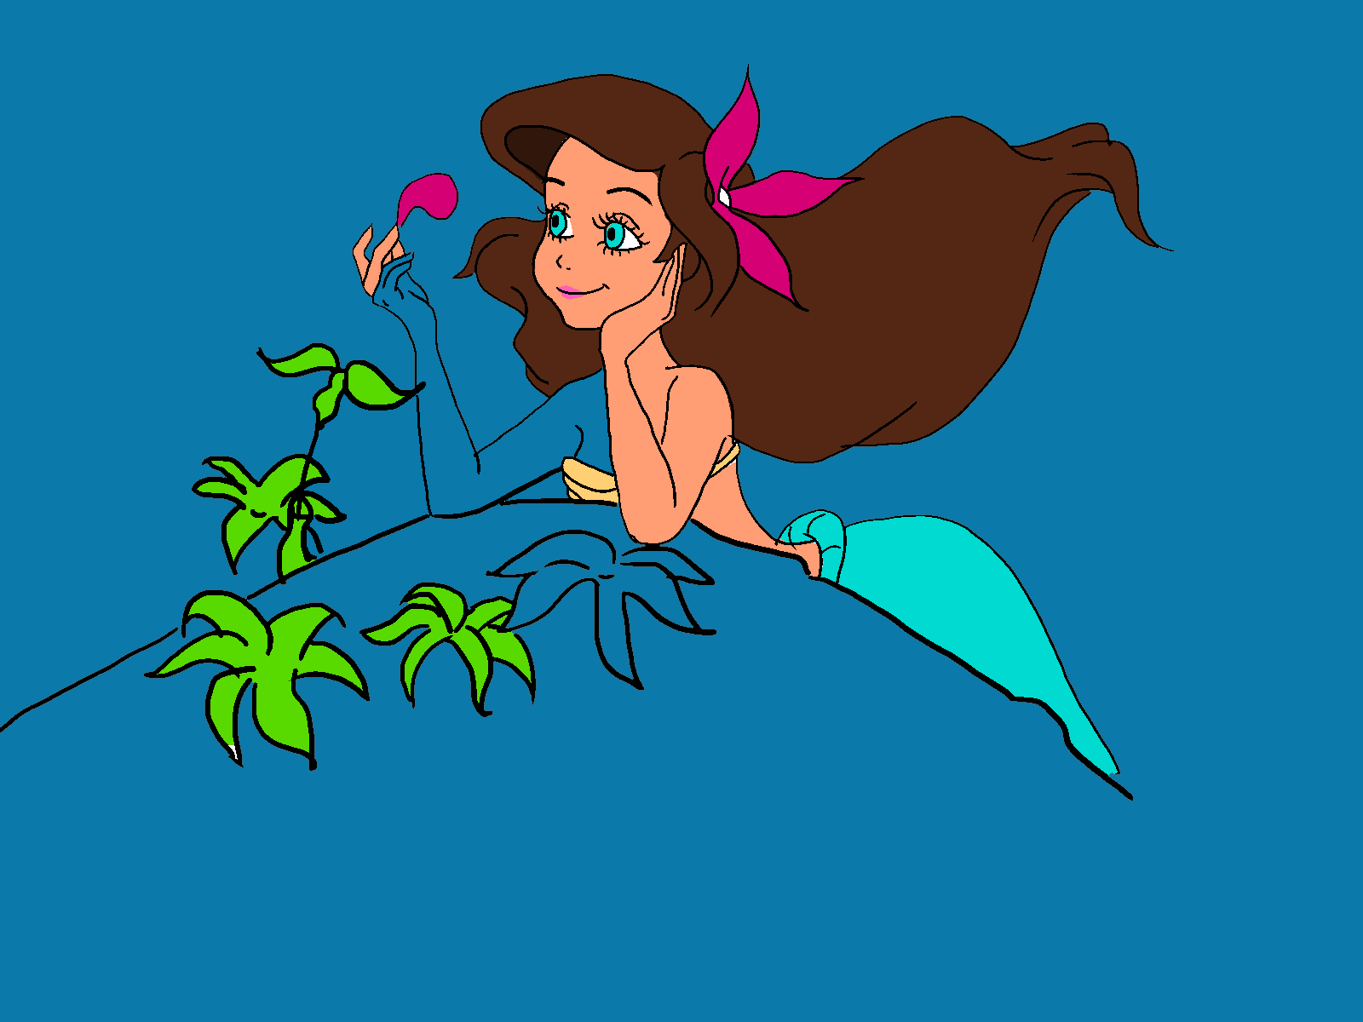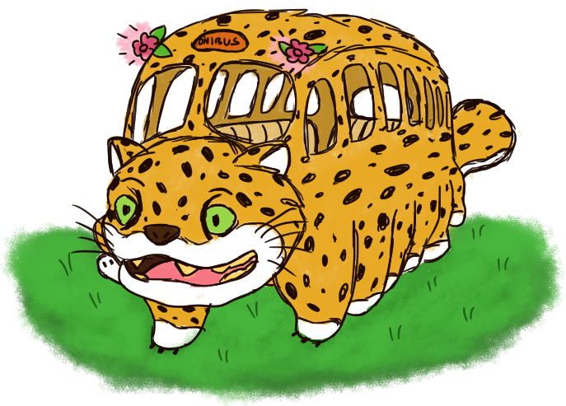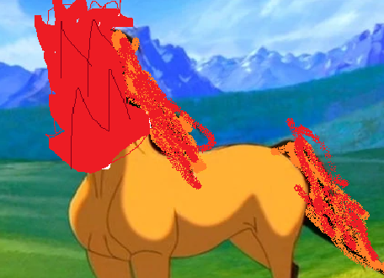
These are some of the characters you created!
Now it’s time to do some WRITING about them.

KET

Descreva o seu personagem.
How many ARMS, LEGS, or TAILS do they have? Are they funny? Lazy?
What color are they? Are they big or small? Are they intelligent? Rude? Dangerous?

Escreva um parágrafo, com frases completas.
Copie e cole a figura do seu personagem ao lado do texto.

PET

Write your character’s story. What is their origin? How did they become who they are now? Were they born as they are, or did they change along their lives?
Write 3-4 paragraphs.

