Instituto de Educação Infantil e Juvenil

Inverno, 2020. Londrina, 14 de Julho.

Nome: ____________________________________ Turma: ____________

Área do conhecimento: Inglês | Professor: Leandro

English Individual - ALL

- Shall we have a break from the platform? So let´s focus on reading today.
http://www.teenink.com/

This website is made by teens and for teens. Spend some time reading.
Ou try http://www.magickeys.com/books/
- Read for around 30 min.
- Tell me about your most interesting part on Moodle (texto online)! Do the self-evaluation of the day (D.P.O) . That is it enjoy.
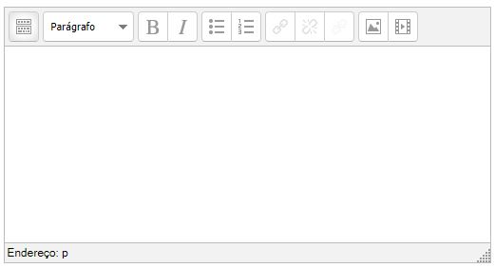

-I will be online during regular class time, you may contact me through:
leandro.ieijf2@gmail.com using e-mail or Hangouts.

