sweet child of mine
Sweet Child of Mine

Alana: violão
Bruna: teclado
Emanuel: guitarra solo e voz
Fabrício: Cajon e voz
Larissa: percussão
Luiza: baixo
Maria Clara: teclado
Nathan: guitarra base
Peter: voz

Alana e Nathan (e Emanuel quando não estiver fazendo solo)
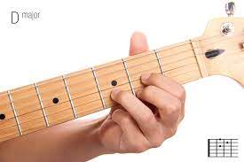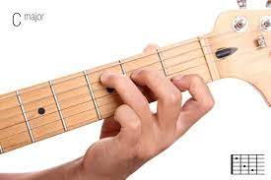
D C G

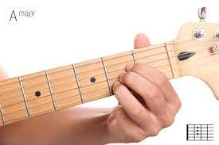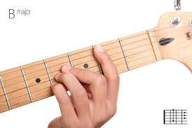
A B

Fabrício: ritmo de rock no cajon
Larissa: meia-lua, como se fosse o prato da bateria
Peter: DECORAR a letra

Luiza: baixo
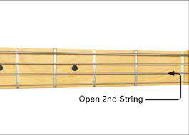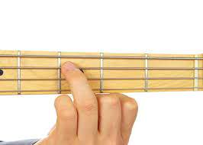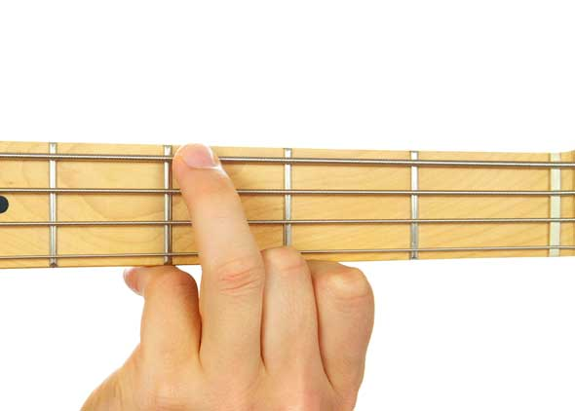
D C G

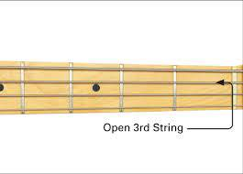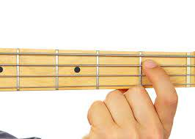
A B

Sequência de acordes para teclado, violão, guitarra e baixo
Estrofe: D C G
Refrão: A B C

Bruna e Maria Clara: teclado
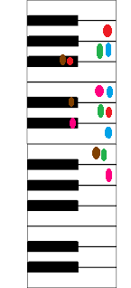

Sweet Child of Mine
Guns N’ Roses

She's got a smile that it seems to me
Reminds me of childhood memories
Where everything was as fresh as the bright blue sky
Now and then when I see her face
She takes me away to that special place
And if I stare too long, I'd probably break down and cry

Whoa, oh, oh
Sweet child o' mine
Whoa, oh, oh, oh
Sweet love of mine

She's got eyes of the bluest skies
As if they thought of rain
I'd hate to look into those eyes and see an ounce of pain
Her hair reminds me of a warm safe place
Where as a child I'd hide
And pray for the thunder and the rain to quietly pass me by

Whoa, oh, oh
Sweet child o' mine
Whoa whoa, oh, oh, oh
Sweet love of mine
Whoa, yeah
Whoa, oh, oh, oh
Sweet child o' mine
Whoa, oh, whoa, oh
Sweet love of mine
Whoa, oh, oh, oh
Sweet child o' mine
Ooh, yeah
Ooh, sweet love of mine

Where do we go?
Where do we go now?
Where do we go?
Ooh, oh, where do we go?
Where do we go now?
Oh, where do we go now?
Where do we go? (Sweet child)

Where do we go now?
Ay, ay, ay, ay, ay, ay, ay, ay
Where do we go now?
Ah-ah

Where do we go?
Oh, where do we go now?
Oh, where do we go?
Oh, where do we go now?
Where do we go?
Oh, where do we go now?
Now, now, now, now, now, now, now
Sweet child
Sweet child of mine

