english class liii

PET

1. Read the image below attentively.

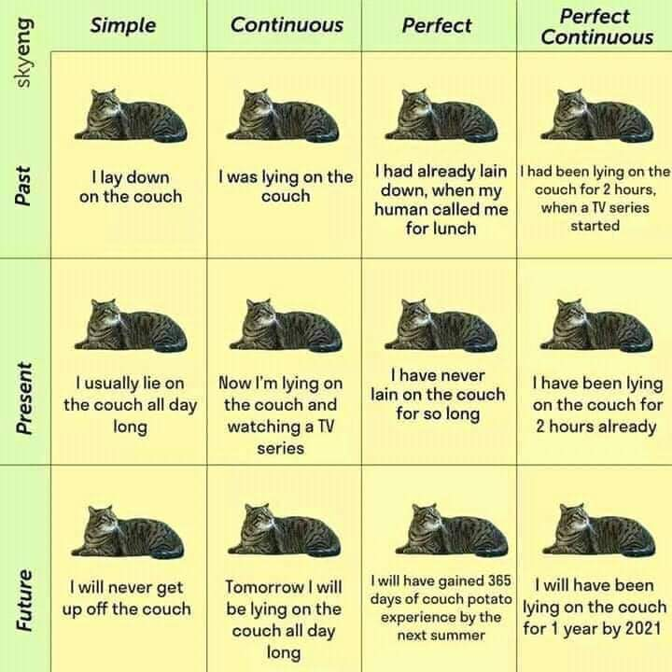

2. Create your own version of the chart, using a subject and a verb that are relevant in your context. Make sure to illustrate it.