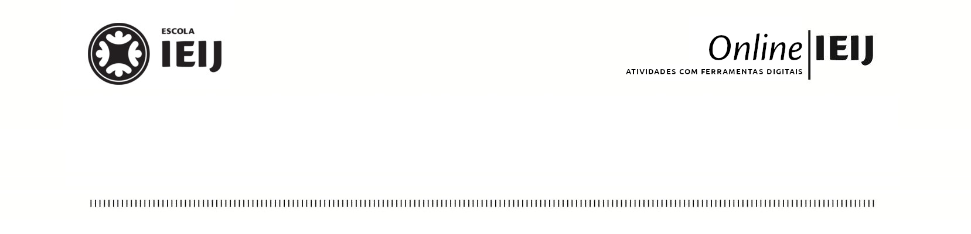

|  |  |  |  |  |  |  |  |  |  |  |  |  |  |  |  |  |  |  |  |  |  |  |  |  |  |  |  |  |  |  |  |  |  |  |  |  |  |  |  |  |  |  |  |  |  |  |  |  |  |  |  |  |  |  |  |  |  |  |  |  |  |  |  |  |  |  |  |  |  |  |  |  |  |  |  |  |  |  |  |  |  |  |  |  |  |  |  |  |  |  |  |  |  |  |  |  |  |  |  |  |  |  |  |  |  |  |  |  |  |  |  |  |  |  |  |  |  |  |  |  |  |  |  |  |  |  |  |  |  |  |  |  |  |  |  |  |  |  |  |  |  |  |  |  |  |  |  |  |  |  |  |  |  |  |  |  |  |  |  |  |  |  |  |  |  |  |  |  |  |  |  |  |  |  |  |  |  |  |  |  |  |  |
| --- | --- | --- | --- | --- | --- | --- | --- | --- | --- | --- | --- | --- | --- | --- | --- | --- | --- | --- | --- | --- | --- | --- | --- | --- | --- | --- | --- | --- | --- | --- | --- | --- | --- | --- | --- | --- | --- | --- | --- | --- | --- | --- | --- | --- | --- | --- | --- | --- | --- | --- | --- | --- | --- | --- | --- | --- | --- | --- | --- | --- | --- | --- | --- | --- | --- | --- | --- | --- | --- | --- | --- | --- | --- | --- | --- | --- | --- | --- | --- | --- | --- | --- | --- | --- | --- | --- | --- | --- | --- | --- | --- | --- | --- | --- | --- | --- | --- | --- | --- | --- | --- | --- | --- | --- | --- | --- | --- | --- | --- | --- | --- | --- | --- | --- | --- | --- | --- | --- | --- | --- | --- | --- | --- | --- | --- | --- | --- | --- | --- | --- | --- | --- | --- | --- | --- | --- | --- | --- | --- | --- | --- | --- | --- | --- | --- | --- | --- | --- | --- | --- | --- | --- | --- | --- | --- | --- | --- | --- | --- | --- | --- | --- | --- | --- | --- | --- | --- | --- | --- | --- | --- | --- | --- | --- | --- | --- | --- | --- | --- | --- | --- | --- |
| **Jogo olhar atento para a matemática no mundo**    ***Parte 1***  Encontrem objetos em sua casa, conforme as características abaixo e apresente-os na chamada para a pontuação.  Tempo para explorar a sua residência (com todo o cuidado do mundo para a sua mãe não surtar) e encontrar o máximo de objetos possível.   1. Números que representam algo; 2. O maior número que encontrar; 3. Algo que possivelmente tenha sido construído com o auxílio de cálculos mais complexos e medidas mais precisas; 4. Algo cujo a forma não tenha curvas, somente superfícies e bordas retas; 5. Algo que tenha círculos dentro de círculos; 6. Algo cujo a forma só tenha superfícies curvas; 7. Algo composto pela composição de quadrados ou retângulos; 8. Um objeto utilizado para medir volume; 9. Um objeto utilizado para medir massa; 10. Um objeto para medir distância exceto a régua; 11. Um objeto para medir tempo e que não seja o relógio; 12. Um grupo de coisas similares ordenadas do menor para o maior.  |  |  |  |  |  |  |  |  |  |  |  |  |  |  | | --- | --- | --- | --- | --- | --- | --- | --- | --- | --- | --- | --- | --- | --- | | **Aluno(a)** | 1 | 2 | 3 | 4 | 5 | 6 | 7 | 8 | 9 | 10 | 11 | 12 | Total | | **Ana V. P** |  |  |  |  |  |  |  |  |  |  |  |  |  | | **Ana R** |  |  |  |  |  |  |  |  |  |  |  |  |  | | **Guilherme** |  |  |  |  |  |  |  |  |  |  |  |  |  | | **Jerônimo** |  |  |  |  |  |  |  |  |  |  |  |  |  | | **Joana** |  |  |  |  |  |  |  |  |  |  |  |  |  | | **João** |  |  |  |  |  |  |  |  |  |  |  |  |  | | **Lucas** |  |  |  |  |  |  |  |  |  |  |  |  |  | | **Luísa** |  |  |  |  |  |  |  |  |  |  |  |  |  | | **Manuela** |  |  |  |  |  |  |  |  |  |  |  |  |  | | **Maria** |  |  |  |  |  |  |  |  |  |  |  |  |  | | **Rafael** |  |  |  |  |  |  |  |  |  |  |  |  |  | | **Tainá** |  |  |  |  |  |  |  |  |  |  |  |  |  | |