english homework I
PET
Teacher Julia
Greetings, fellow earthmen!
Below you will see a series of humorous texts and images. They are called comic strips.

1. After reading the two comics, explain: what is their most relevant characteristic?
In other words, why can they be considered funny?
________________________________________________________________________________
________________________________________________________________________________
________________________________________________________________________________

2. Read two other comics by the same artist (Nathan W. Pyle).
Then, on the copies that follow, rewrite the dialogue in a more colloquial style.

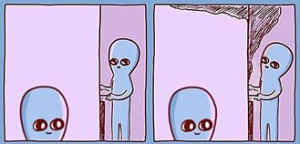

← rewrite here

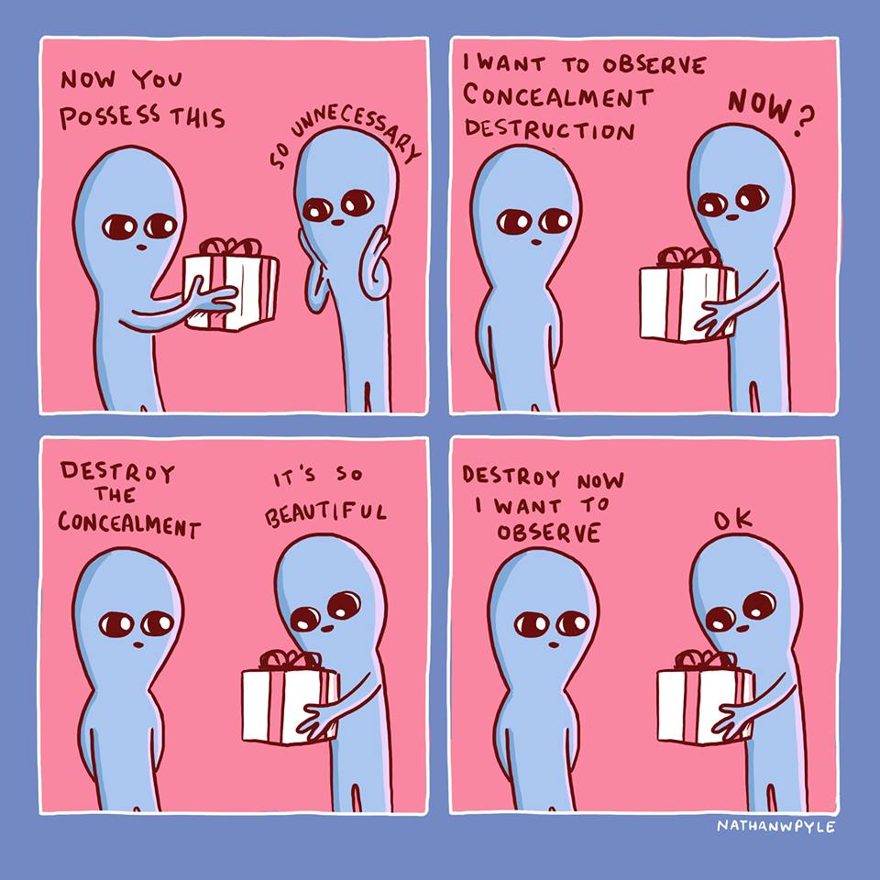

rewrite here →

