english homework Iv

KET

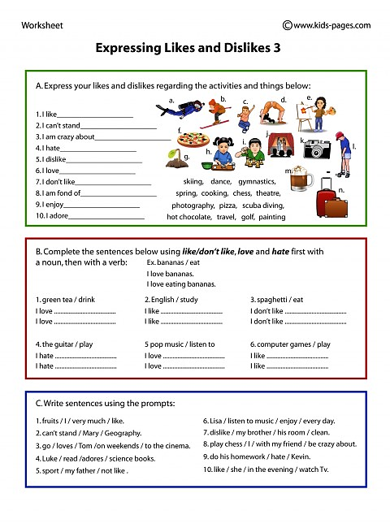*Teacher Julia*