english homework vi
KET
Teacher Julia
1. Look at the picture below. Write T for TRUE sentences or F for FALSE sentences.
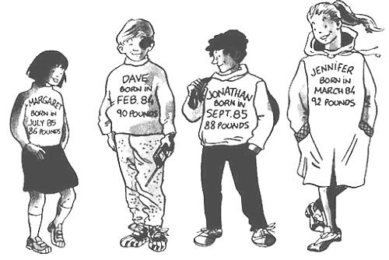
( ) Dave is taller than Margaret. ( ) Jennifer is the tallest.
( ) There are two boys and three girls. ( ) Jennifer is younger than Margaret.
( ) Jonathan has a backpack. ( ) They are all wearing sneakers.
( ) The boys are wearing trousers. ( ) Dave is older than Jonathan.
( ) They are all smiling. ( ) Margaret is wearing socks.

3. You are visiting an Art Gallery. Look at the sign below and answer the questions:

- What time does the Gallery open on Sundays? ____________________________________
- How much does an audio guide cost? ____________________________________
- Is food allowed in the gallery? ____________________________________
- Can you take your dog to the gallery? ____________________________________

2. What’s the weather like right now? Crie uma tabela com a previsão do tempo para os próximos 7 dias. Com a ajuda de um dicionário, registre a previsão em inglês.

