english homework vii
KET
Teacher Julia

1. Can you crack the code? Unscramble the words and rewrite the sentences.
Thsi si tAnhoyn. Hs’e ym sbet rfeind! Wr’ee sundtest nad ew klie ot layp ketbasllba.
eH is zycar baout psorts, utb he n’tca sdant ccsore.

______________________________________________________________________________
______________________________________________________________________________
______________________________________________________________________________
______________________________________________________________________________

2. WHAT IS THE WEATHER LIKE? Write sentences according to the symbols.

Example: It’s cold and snowy.

__________________________________________________

__________________________________________________

__________________________________________________

__________________________________________________

3. Draw the weather conditions according to the sentences.
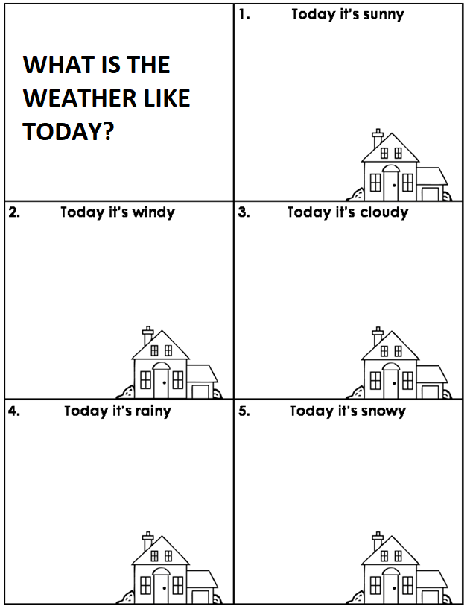

4. Fill in the table with the correct pronouns:
 | my
 |  | yours
 | her
 |  | his
we |  | ours
 | their
it

