english homework vii
PET
Teacher Julia

1. Fill in the gaps with when, until or after.

a) __________ we arrived, they had already left.
b) They are staying __________ they’re finished.
c) I was reading __________ you called me.
d) We watched a movie __________ dinner.
e) The movie came out __________ the book.

2. Match the explanations with the sentences.

She must be in her office.

She should be in her office.

She may be in her office.

She could be in her office.

She can’t be in her office.

3. Match the sentences to make seven short conversations.
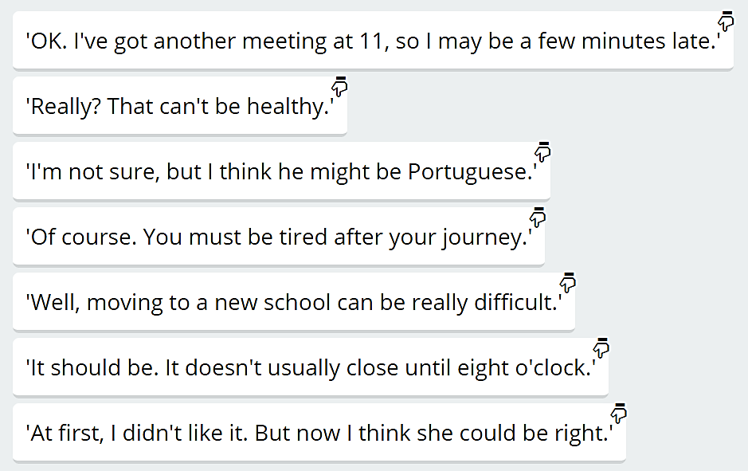
'Did you know that Barry works every weekend?'
__________________________________________________________________________________
'What did you think about Alison's idea?'
__________________________________________________________________________________
'I'll see you in the meeting at noon tomorrow.'
__________________________________________________________________________________
'Mark's son started a new school last month. He doesn't like it at all.'
__________________________________________________________________________________
'I think I'll go to bed now.'
__________________________________________________________________________________
'Do you know where Dave's from? I don't recognise his accent.'
__________________________________________________________________________________
'Do you think the supermarket's still open?'
__________________________________________________________________________________

4. Fill in the gaps with the correct modal verb.

I don't know where Eliza is. She ____________ be in her office.

Eliza's a good boss, but she ____________ be difficult sometimes.

We can invite Filip to dinner tonight, but I think he ____________ be too tired.

Don't feed that dog. You don't know where it's from. It ____________ be dangerous.
You shouldn't walk home alone. This city ____________ be dangerous at night.

Sometimes, the temperature in Antarctica ____________ be less than –50°C.

Please, don't tell John about our meeting. He ____________ be angry.

There are many different types of tea. It ____________ be white, yellow, green or black.

5. COMPLAINTS
You went to a restaurant and the food was cold. What would you say?
________________________________________________________________________________________________________________________________________________________________

You bought a product that doesn’t work. What would you say?
________________________________________________________________________________________________________________________________________________________________

6. Rewrite the sentences in the correct category:

REQUESTS
________________________________________________________________________
________________________________________________________________________
________________________________________________________________________
________________________________________________________________________

OFFERS/INVITATIONS
________________________________________________________________________
________________________________________________________________________
________________________________________________________________________
________________________________________________________________________

