fashion revolution
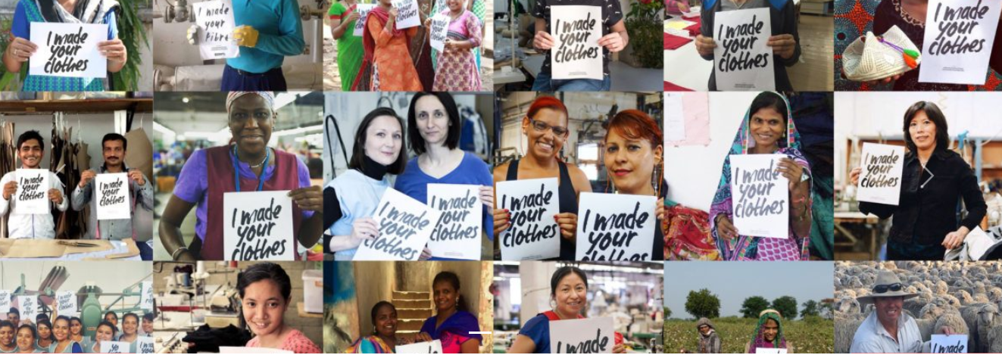

WE ARE FASHION REVOLUTION
Fashion Revolution is a global movement calling for greater transparency,
sustainability and ethics in the fashion industry.
We want to unite the fashion industry and ignite a revolution to radically change the way our clothes are sourced, produced and purchased, so that what the world wears has been made in a safe, clean and fair way.

Fashion Revolution Brasil and the reNature Foundation launch the Fashion for the Amazon Rainforest campaign
By Fernanda Simon
Fashion for the Amazon: catalyze action to regenerate the rainforest
The Amazon is the largest rainforest in the world: it comprises the largest river basin on the planet, including 2,500 tree species and 30,000 types of other plants, and 60% of its territory is located in Brazil.
Besides the enormous natural wealth, the biome breathes culture and ancestry through natural medicine, weaving, cooking and oral traditions. The indigenous peoples of the region hold shares of lands that are fundamental to forest preservation and balance.
Fashion, as an important social system and industry that uses numerous natural and human resources, has great relations with the Amazon territory. Art, culture and craftsmanship intersect in the daily lives of indigenous peoples where the act of dressing tells a story of resistance and celebrates the origins of the earth. However, the relationship also has negative effects: since 1988, 42.8 million hectares of Brazilian Amazon has been deforested to raise cattle, which is almost twice the length of the United Kingdom.
Livestock is a market that drives fashion as well: cattle breeding is not only used for meat production and consumption, but also for leather. The tannery sector in Brazil sold, only in July 2019, $84.2 million to foreign markets. In addition to its production being linked to deforestation, handling it also brings other problems: one of the main materials used in tanning is chrome – a corrosive chemical that can contaminate water and soil.
Given this scenario, can the power of fashion be channeled into the preservation and regeneration of the Amazon rainforest? If we mobilize ourselves individually and collectively, the answer is yes.
For this reason, we present the Fashion for the Amazon Rainforest campaign, a partnership between Fashion Revolution Brasil and the reNature Foundation, to foster awareness and information about the impacts of fashion on forests, inviting everyone to engage in its regeneration processes. The action aims to inspire people and businesses to connect with the forest through the power of fashion, and to regenerate 100,000 hectares of degraded land by 2025 using agroforestry.
In the next months, awareness campaigns, citizens manifestos, letters of commitment to companies and donations to fund the implementation of agroforestry will be organized.
Fashion Revolution Brasil and the reNature Foundation believe that fashion has the power to inspire, communicate and transform. Let’s use this force together for the regeneration of the Amazon?

While the rainforest burns, we need to know where our leather comes from
Fashion Revolution shares the world’s condemnation of the burning of the Amazon Rainsforest, not least because of its links with the fashion, footwear and accessories industries. Scientists at Brazil’s National Institute of Space Research calculate that there have been 35% more fires so far this year than average in the last eight years.
Brazil is the second biggest exporter of beef supplying 20% of the world’s beef (second only to America). It follows that Brazil’s cattle rangers are supplying the same proportion of the world’s leather. The fashion industry must take responsibility for the leather handbags, shoes and accessories contributing to the deforestation of the rainforests.
Many brands were implicated in sourcing their leather from cattle reared in rainforest affected by deforestation by a Greenpeace report Slaughtering the Amazon in 2009. While several brands rushed to distance themselves from the report, ten years on, there is little progress in terms of transparency on leather sourcing for shoes, handbags and leather goods. As the devastation caused by clearing the rainforest for cattle rearing is increasingly condemned globally, it is not good enough for brands not to give full disclosure on the sourcing of their raw materials, particularly leather.
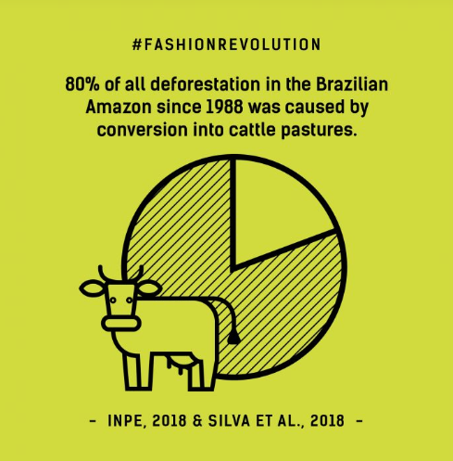

A brief survey of a few luxury brands this week revealed no information whatsoever about the country of origin of leather used. “Italian leather” simply means the leather was tanned and processed in Italy. The origins of the hides is obscure and the supply chains opaque, hiding a whole range of issues including the welfare of the animals. As citizens we must demand the right to know where the leather we are buying has been sourced – and that brands are not contributing to the deforestation of the Amazon Rainforest.
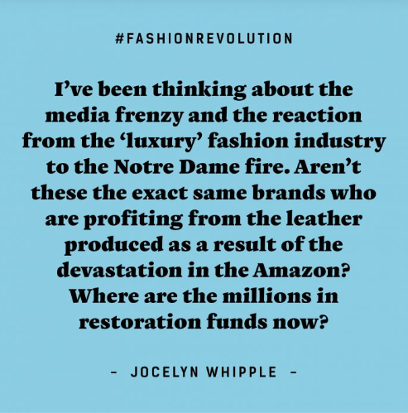

PROPOSTA:
Utilize os papéis adesivos e faça os posts como os da campanha da Fashion Revolution.
Apresente, no mínimo, 5 ideias do texto lido. Ilustre com desenhos de traços simples.
