english homework i
PET
Teacher Julia
1. Read the text below and highlight the parts with the most important information.

Allyson Felix breaks one of Usain Bolt’s world records, 10 months after giving birth

Allyson Felix is on the biggest runner’s high of her life after smashing one of Usain Bolt‘s world records on Sunday in Qatar.

She took home her 12th gold medal at the World Championships on the mixed-gender 4×400 relay team, beating Bolt who previously held the record for most golds won at the track-and-field competition. He won 11 gold medals at the same championship event before he retired in 2017.

Her response to the record break was simple: “Humbled,” she wrote on Instagram, paired with a photo of herself decorated in medals.
“I think everything I went through this year … it just brings it all back that it’s so much bigger than myself,” Felix told ESPN at the world championships in Doha, Qatar.
While the record-breaking event is a feat in its own, Felix did it all just 10 months after giving birth to her daughter, Camryn — and it hasn’t been easy for her getting back to track level.
Just before her daughter was born in November 2018, the Olympian struggled with preeclampsia, a condition in pregnancy that causes high blood pressure. She was forced to undergo an emergency C-section at 32 weeks.
In September last year, the 33-year-old shared an emotional post about the time she spent in NICU (neonatal intensive care unit) prior to welcoming her daughter.
“The NICU is a heavy place. I never imagined motherhood would start there for me,” states her post, paired with a photo of her sleeping in a hospital chair. “Oftentimes, I would head down to get lunch and find myself in the elevator with a family getting discharged and be in tears hoping our day was coming soon.”
“I know many families who had and continue to have much more difficult paths than ours,” it continues. “Much longer stays and more complex issues. No matter the circumstances you are never prepared.”
Felix is currently training for the 2020 Summer Olympics in Tokyo, and she’s the most successful female track athlete in Olympic history.

2. Summarize the news based on the information you highlighted.
________________________________________________________________________________
________________________________________________________________________________
________________________________________________________________________________
________________________________________________________________________________
________________________________________________________________________________
________________________________________________________________________________

3. Create a “true or false” activity for the text and answer it.

________________________________________________________________________________
________________________________________________________________________________
________________________________________________________________________________
________________________________________________________________________________
________________________________________________________________________________
________________________________________________________________________________

4. Do the crossword puzzle below:
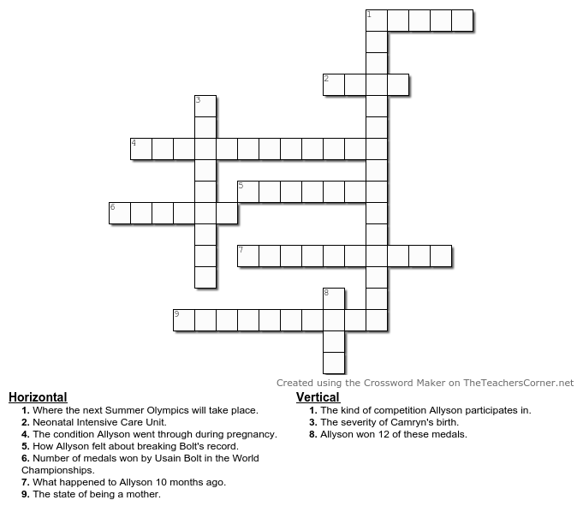

5. Do you enjoy playing and/or watching sports? Which one is your favorite? Describe it and explain why you like it. Mention a team or athlete that is relevant in that sport.
________________________________________________________________________________
________________________________________________________________________________
________________________________________________________________________________
________________________________________________________________________________
________________________________________________________________________________
________________________________________________________________________________
________________________________________________________________________________
________________________________________________________________________________

