english homework Iii
KET
Teacher Julia

Congratulations, dear student! You bought a house!
This is your new house:
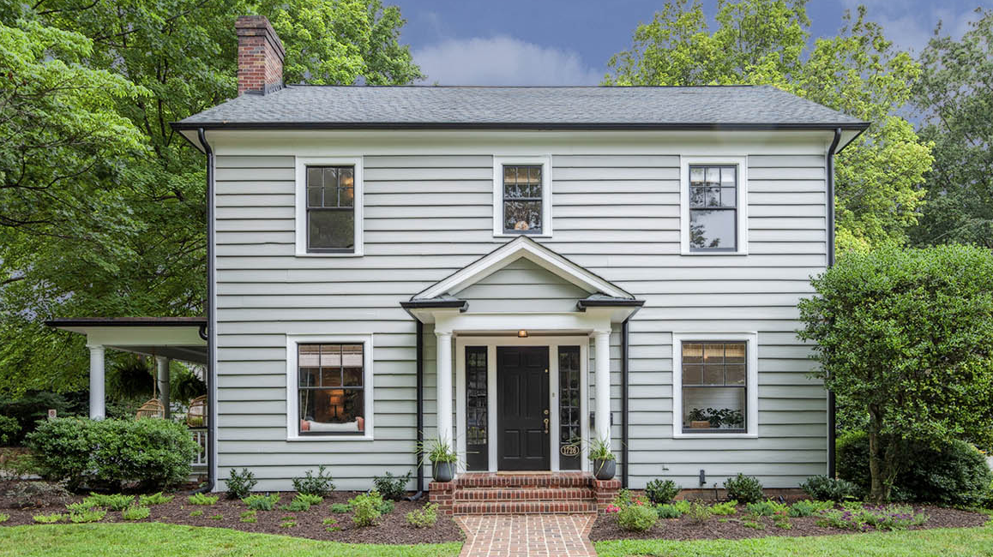

Beautiful, right? Now it’s time to buy some furniture.
I) You have £6500,00 to spend. Look at the catalogue below and circle the items you want to buy.

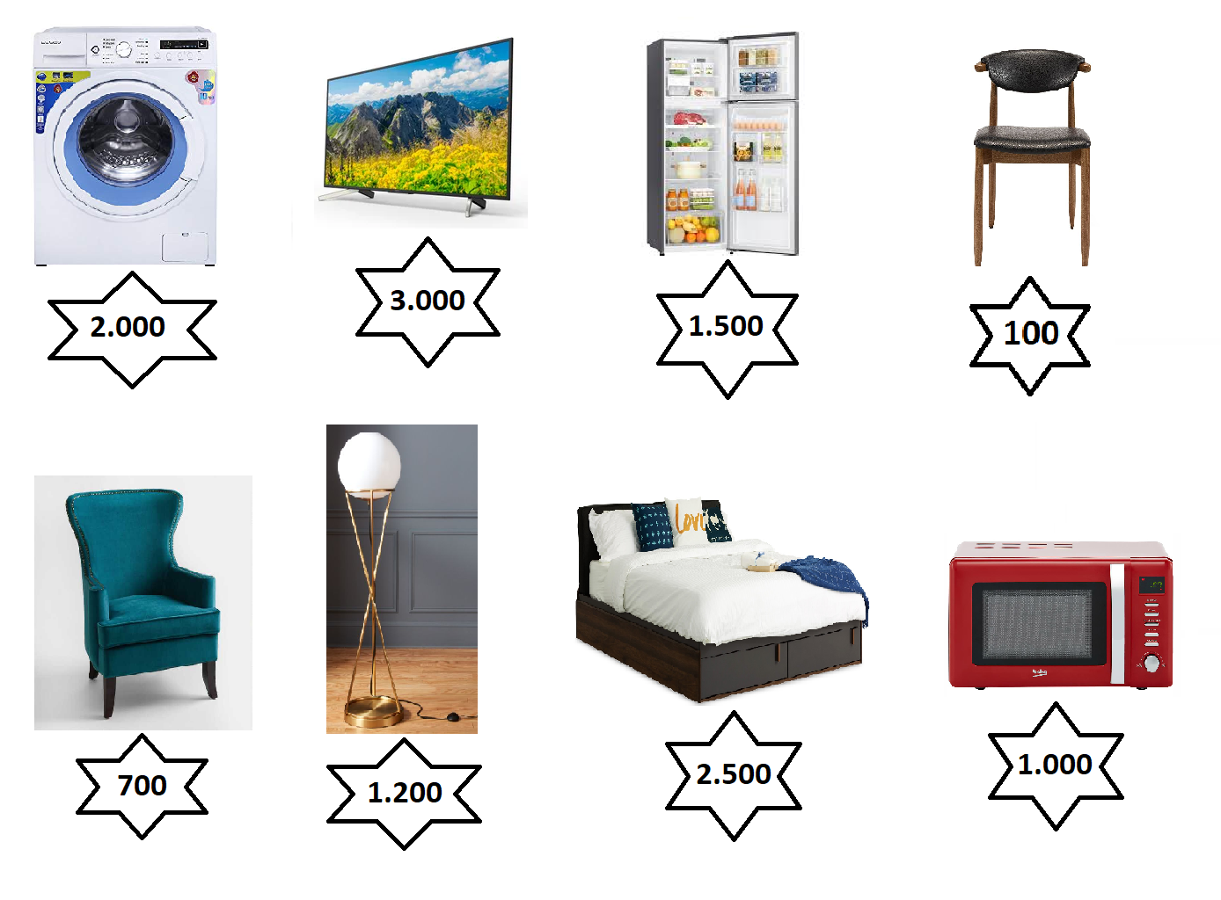

II) How much money did you spend?
____________________________________________________________________________

III) Now, make sentences about your house. Use a dictionary if you need to.
Ex: There is a bed. // There isn’t a floor lamp. // There are two chairs.
____________________________________________________________________________
____________________________________________________________________________
____________________________________________________________________________
____________________________________________________________________________
____________________________________________________________________________

IV) Choose a part of your house (bedroom, bathroom, kitchen…) and describe it. Write about what you like doing in that place.
Ex: My living room is big and beautiful. There is a green table and four white chairs. The walls are grey. There are many pictures on the walls. There are plants and CDs. I love listening to music and watching series in the living room…
____________________________________________________________________________
____________________________________________________________________________
____________________________________________________________________________
____________________________________________________________________________
____________________________________________________________________________
____________________________________________________________________________
____________________________________________________________________________

V) Draw the room from exercise IV with the objects you mentioned.

