o avião
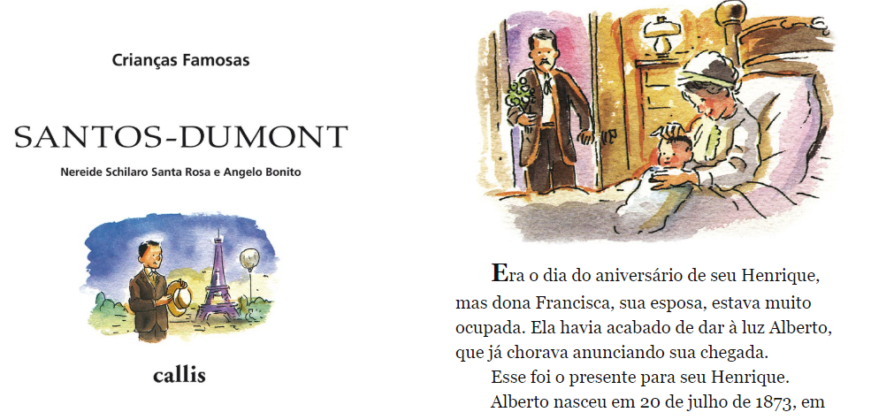
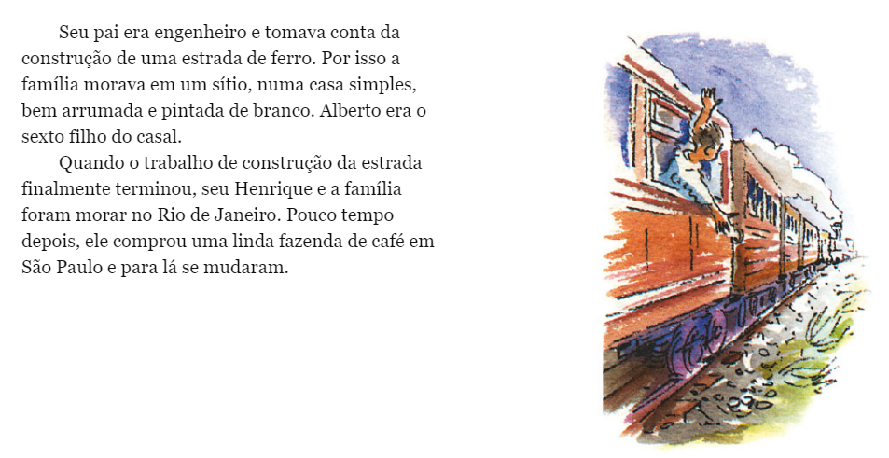

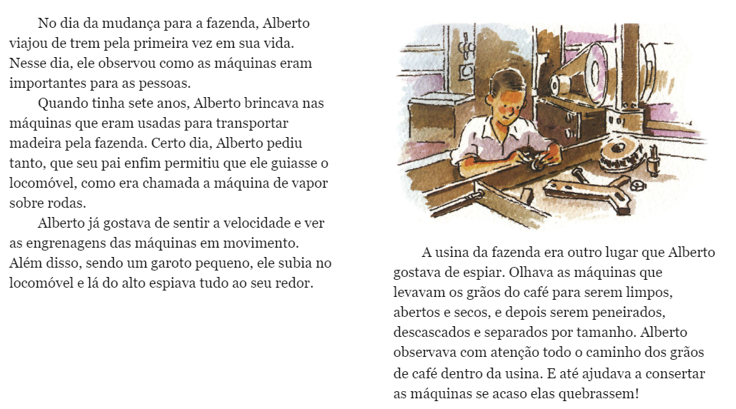
PROPOSTA:
Após a leitura desse trecho do livro SANTOS DUMONT – CRANÇAS FAMOSAS, faça um resumo do texto utilizando somente 30 palavras.
_____________________________________________________________________________________________________________________________________________________________________________________________________________________________________________________________________________________________________________________________________________________________________________________________________________________________________________________________________________________________________________________________________________________________________________________________________________________________________________

