o avião

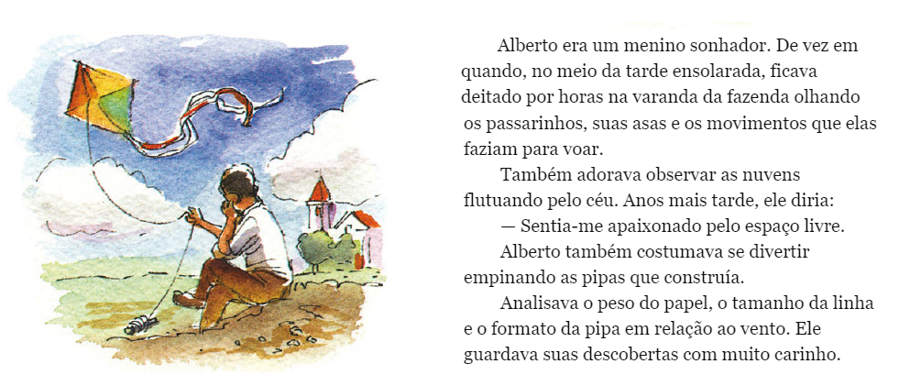
PROPOSTA:
Após a leitura desse trecho do livro SANTOS DUMONT – CRANÇAS FAMOSAS, faça um resumo do texto utilizando somente 50 palavras.

__________________________________________________________________________________________________________________________________________________________________________________________________________________________________________________________________________________________________________________________________________________________________________________________________________________________________________________________________________________________________________________________________________________________________________________________________________________________________________________________________________________________________________________

