english homework v
KET
Teacher Julia
1. Leia a tirinha abaixo:
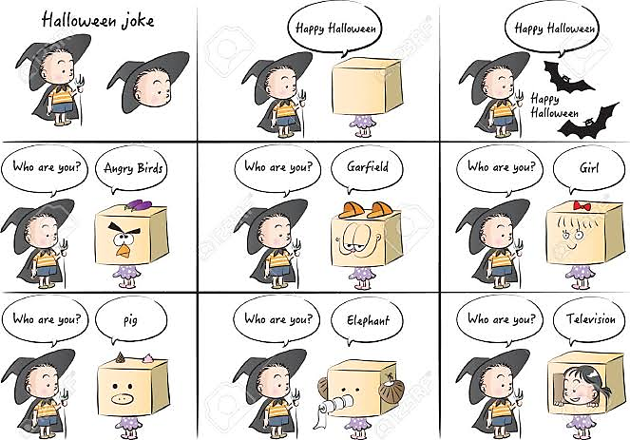

2. Agora, desenhe um quadrinho seguindo o modelo de diálogo da história acima. Que fantasias você estaria usando? Use a caixa de formas criativas!
3. Leia a charge abaixo:
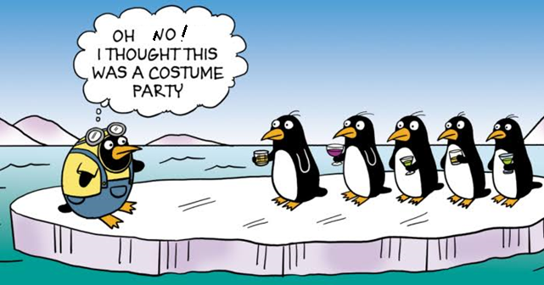

a) Explique o sentido da charge.

b) Descreva o que há na imagem.

c) Compare a charge da atividade 3 e a tirinha da atividade 1. Use comparativos (cuter, funnier, more interesting…).

________________________________________________________________________________
________________________________________________________________________________
________________________________________________________________________________
________________________________________________________________________________
________________________________________________________________________________
________________________________________________________________________________
________________________________________________________________________________
________________________________________________________________________________
________________________________________________________________________________
________________________________________________________________________________
________________________________________________________________________________
________________________________________________________________________________
________________________________________________________________________________
________________________________________________________________________________

