english homework ix
PET/KET
Teacher Julia
1. Christmas is right around the corner! Can you find all the words in the puzzle?
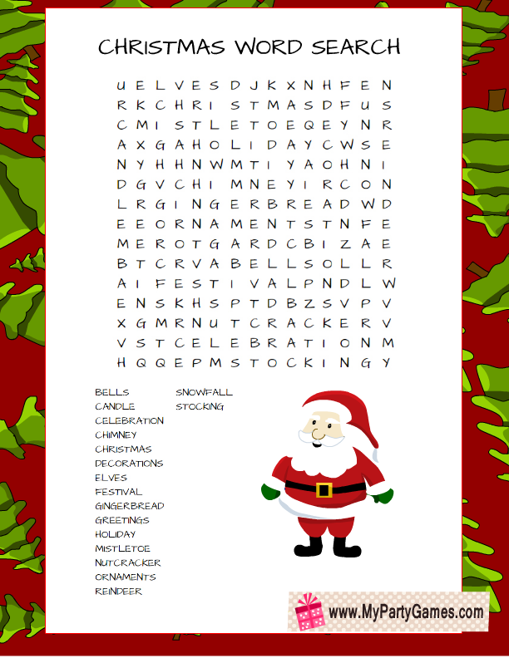
2. Some religions, like Judaism, celebrate different events during this time of the year. Do you know Hanukkah? Find the words below!
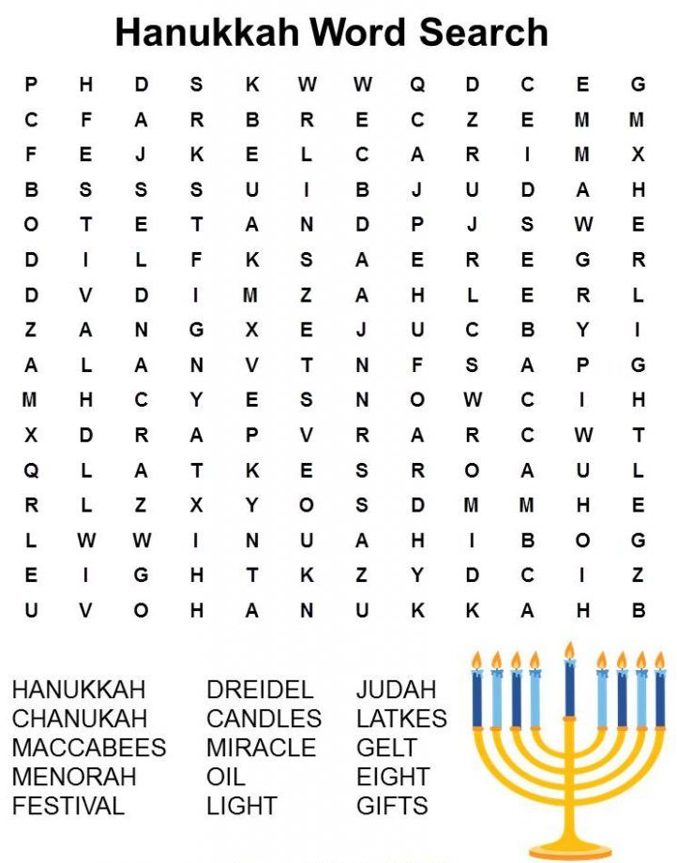

3. Write the meaning of the words below. You can look them up, if you need to.
MACCABBES:_____________________________________________________________________
MENORAH:_______________________________________________________________________
DREIDEL:_________________________________________________________________________
LATKES: :_________________________________________________________________________
GELT:____________________________________________________________________________
4. Do you celebrate any holidays in the end of the year? Draw a picture OR comic strip in the space below, showing how you and/or your family celebrate a special holiday.

