english homework vii
PET
Teacher Julia

1. We’re making a manual together. It includes some tips on how to stay safe and sane during the COVID-19 shutdown.

- Create a title for the manual (make it big and beautiful)
- Illustrate the blank spaces according to their subtitles (you can take photos of yourself, use google images or create something using Paint/Gimp/Photoshop/etc) and write a sentence about that advice;
- Write subtitles for the pictures that are there;
- Write your own tip at the end of the manual and illustrate it!

_______________________________________________________________________________
(Your big and beautiful title here)
By:

1. Maintain principles of self-care, i.e. take care of yourself

2. ____________________________________________________________________________
In spite of being forced to remain at home, those quarantined should try to limit their isolation.
“When they feel stressed, people should call someone and chat or talk to those living with them and express what is making them feel stressed.”
“Anxiety is exacerbated in conditions of uncertainty,” she said. “Talking about what we can do within the constraints of the situation will help people feel they are in control.”

3. Do what helps you relax

4. ____________________________________________________________________________
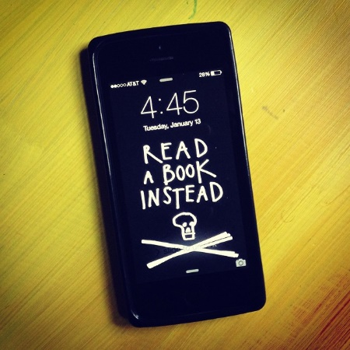
“People should not spend too much time sitting,” she said. “Also, parents should realize that keeping children in front of a TV or video games does not help with their level of stress.”
Checking the news compulsively should be avoided, she said, adding: “It is okay to want to be informed, but not all the time, because this keeps us in a state of alertness and anxiety, which stresses adults but also children.”

5. ____________________________________________________________________________
“People should not feel embarrassed or stigmatized if they are feeling distressed,” Cwikel said. “A lot of people are on the same boat.”

6. Keep physically active from your living room using online resources

7. _____________________________________________________________________________

If you need help with your manual or want to read more, go to https://www.jpost.com/HEALTH-SCIENCE/Coronavirus-seven-tips-on-how-to-avoid-going-stir-crazy-in-quarantine-620767

