Para onde foram todos os insetos?
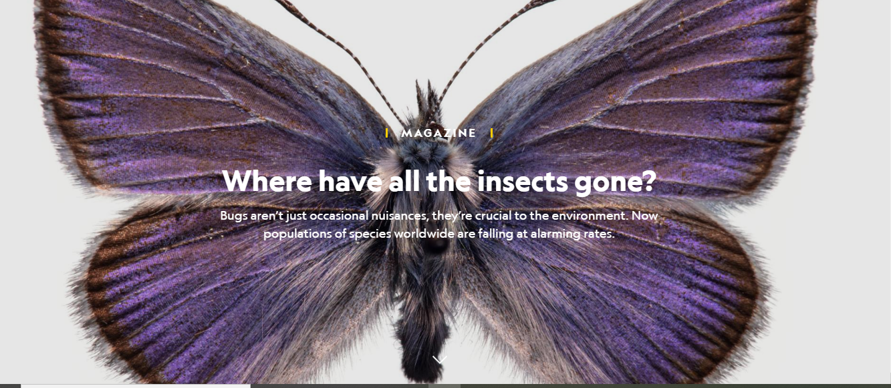
BY ELIZABETH KOLBERT
PHOTOGRAPHS BY DAVID LIITTSCHWAGER
Esta história aparece na edição de maio de 2020 da revista National Geographic.

THE BUTTERFLIES JUST kept coming—at first thousands, then tens or even hundreds of thousands. Their wings were brown on the underside and vivid orange above, so as they flew by, they looked like chips of sunshine. The sight was marvelous, awe-inspiring, and more than a little disconcerting.
I encountered the butterfly cloud—technically, an irruption of California tortoiseshells —on a bright blue summer day in the Sierra Nevada. Along with Matt Forister, a biologist from the University of Nevada, Reno, I was hiking Castle Peak, a knob-shaped mountain northwest of Lake Tahoe. Castle Peak’s butterflies are one of the world’s most closely watched insect populations: Every summer for nearly 45 years they’ve been censused on a biweekly basis. Most of the data were collected by Forister’s mentor, Art Shapiro, a passionate lepidopterist and professor at the University of California, Davis, who recorded the information on three-by-five cards.
After Forister and his team computerized the surveys and analyzed them, they found that Castle Peak’s butterflies have been in decline since 2011. We were discussing why this was the case when we neared the 9,100-foot summit and were enveloped in an orange haze.
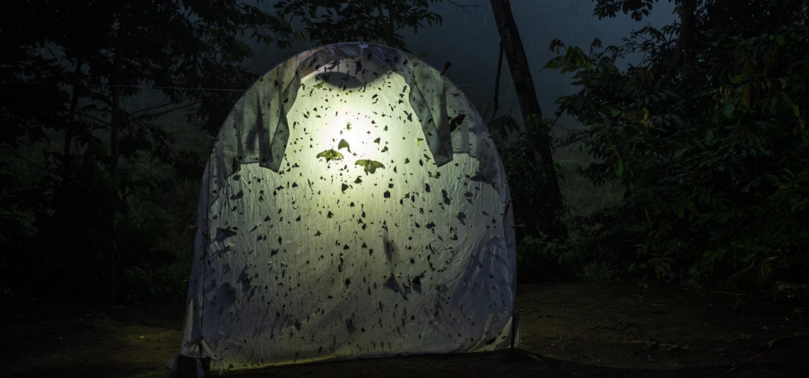
A backlit sheet collects an abundance of night-flying insects at a field station in the Ecuadorian Amazon. At less remote sites, light traps show steep drops in insects—as do car windshields. Climate change, habitat loss, and pesticides have all been implicated.

“The idea that insects are suffering seems shocking to people, which I understand,” Forister said. He gestured at the butterflies streaming by: “Insects do this, so it does seem weird.”
It’s said that we live in the Anthropocene—an epoch defined by human impacts on the planet. Still, by many measures, it’s bugs that dominate the world. At any given moment, it’s been estimated, there are 10 quintillion insects flying, crawling, hovering, marching, burrowing, and swimming around. In terms of variety, the numbers are equally impressive: Something like 80 percent of all the different kinds of animals are insects. They maintain the world as we know it: Without insects to pollinate them, most flowering plants, from daisies to dogwoods, would die out.
If humans were to suddenly disappear, biologist Edward O. Wilson has famously observed, the Earth would “regenerate back to the rich state of equilibrium that existed 10,000 years ago.” But “if insects were to vanish, the environment would collapse into chaos.”
It is, therefore, shocking—and alarming—that in most places scientists have looked recently, they’ve found that insect numbers are falling. This is the case in agricultural areas and in wild places like Castle Peak. Quite probably, it’s also happening in your own backyard.

WHAT’S BEEN LOST
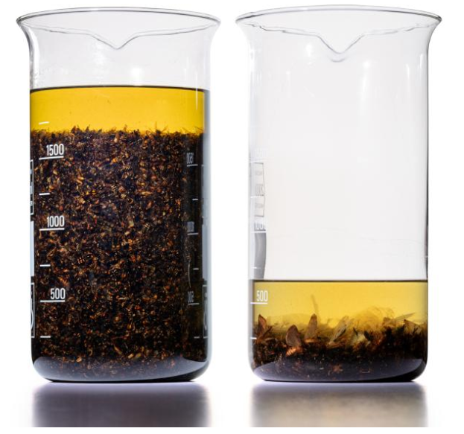
Entomologists from Krefeld, Germany, collected flying insects for two weeks in August 1994 (left) and—at the same site, with an identical trap —in August 2016 (right). Similar data from 63 German protected areas overall gave a shocking result: a 76 percent drop in insect biomass between 1989 and 2016.

The Entomological Society of Krefeld, Germany, on the Rhine River not far from the Dutch border, stores its collections in a former schoolhouse. Where kids used to fidget through class, the rooms now hold boxes filled with bottles, and the bottles, in turn, are filled with clumps of dead insects floating in ethanol. If there were a ground zero for the exploding concern about insect decline, the schoolhouse would be it.
“We don’t count the bottles, because the number changes every week,” Martin Sorg, the head curator of the collection, told me. He estimates that there are “several tens of thousands.”
In the late 1980s Sorg and his colleagues set out to find how insects were faring in different types of protected areas in Germany. To get a handle on this, they set up what are known as malaise traps, which look like tilted pup tents. The traps caught everything that flew into them, including flies, wasps, moths, bees, butterflies, and lacewings. Whatever a trap caught ended up in a bottle.
The collecting went on for more than 20 years, first in one spot, then another, in 63 protected areas, mostly in the state of North Rhine-Westphalia, where Krefeld is located. In 2013 the entomologists returned to two sites that they’d first sampled back in 1989. The mass of trapped insects was just a fraction of what it had been 24 years earlier. They sampled those sites again in 2014 and set about resampling more than a dozen other sites. Wherever they collected, the results were similar.
To interpret the results, the society enlisted the help of other entomologists and statisticians, who painstakingly sifted through the data. Their analysis confirmed that from 1989 to 2016, flying insect biomass in protected areas in Germany had declined by a whopping 76 percent.
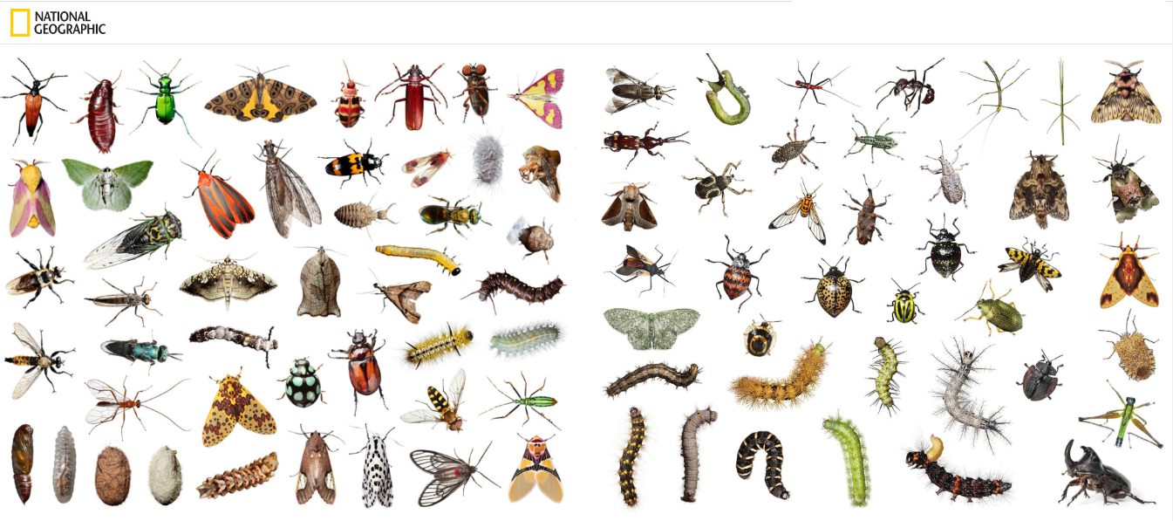
THE WIDE WORLD OF INSECTS
In Arizona, Tennessee, and Ecuador, photographer David Liittschwager made portraits of dozens of bugs in a class (Insecta) that includes millions of species. All, when adults, have six legs, three body segments, and a rigid exoskeleton. Beyond that, diversity rules. Ten groups are represented here: beetles (Coleoptera); cockroaches and termites (Blattodea); butterflies and moths (Lepidoptera); flies (Diptera); true bugs (Hemiptera); bees, wasps, ants, and sawflies (Hymenoptera); walking sticks (Phasmida); alderflies, dobsonflies, and fish flies (Megaloptera); nerve-wings (Neuroptera); grasshoppers, locusts, and crickets (Orthoptera).

PROPOSTA:
Escreva uma frase que resuma cada um dos parágrafos.
1. ___________________________________________________________________
2. ___________________________________________________________________
3. ___________________________________________________________________
4. ___________________________________________________________________
5. ___________________________________________________________________
6. ___________________________________________________________________
7. ___________________________________________________________________
8. ___________________________________________________________________
9. ___________________________________________________________________
10. __________________________________________________________________
11. __________________________________________________________________
12. __________________________________________________________________

Agora, escreva sobre as imagens:
1. ___________________________________________________________________
2. ___________________________________________________________________
3. ___________________________________________________________________
4. ___________________________________________________________________

